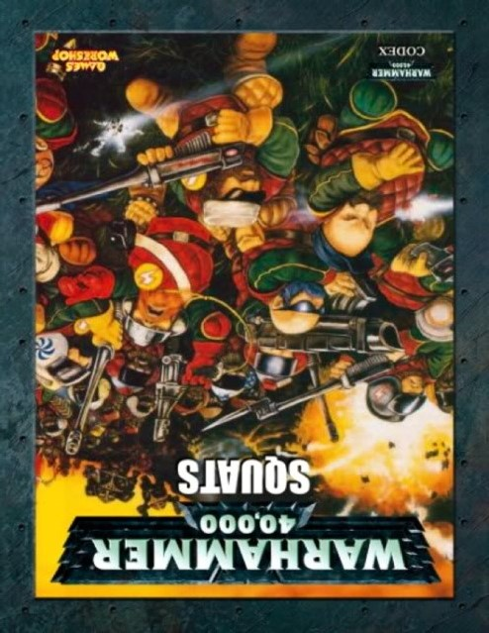
CODEX: SQUAT ISOLATIONISTS

Squat History..........................................................................................................................................................4
Squat Religion and Culture.....................................................................................................................................7
Squat Physiology.....................................................................................................................................................8
Personages of note.................................................................................................................................................9
Army special rules.................................................................................................................................................13
Warlord Traits.......................................................................................................................................................14
Allies Matrix..........................................................................................................................................................14
Noble.................................................................................................................................................................15
Living Ancestor......................................................................................................................................................15
Engineer/ Engineer Guildmaster...........................................................................................................................16
Advisory Council....................................................................................................................................................17
Stormragers..........................................................................................................................................................18
Hearthguard..........................................................................................................................................................18
MkII Exo Armour...................................................................................................................................................19
Mining Guild..........................................................................................................................................................19
Iron Ancestor........................................................................................................................................................20
Squat Warriors......................................................................................................................................................21
Automata..............................................................................................................................................................22
Artillery.................................................................................................................................................................24
Motor Pool............................................................................................................................................................25
Ranged Weapons..................................................................................................................................................31
Melee Weapons...................................................................................................................................................35
Armour.................................................................................................................................................................36
Wargear................................................................................................................................................................37
Runic Items...........................................................................................................................................................40
Vehicle Upgrades..................................................................................................................................................42
Armoury................................................................................................................................................................44
Army List: HQ........................................................................................................................................................46
Army List: Elite......................................................................................................................................................52
Army List: Troops..................................................................................................................................................56
Army List: Transport Vehicles...............................................................................................................................58
Army List: Fast Attack............................................................................................................................................59
Army List: Heavy Support......................................................................................................................................64
The Iron Duke........................................................................................................................................................69
Engineer Grymm...................................................................................................................................................70
Skagg The Stealthy................................................................................................................................................71
Combat Droid AA-23.............................................................................................................................................72
Oswynn Sevrinsdottir............................................................................................................................................72
Summaries............................................................................................................................................................73
Designers Notes....................................................................................................................................................75

Codex: Squat Isolationists

Transmitted to Imperial archives by Inquisitor Severus, as related to him by the Abhuman known as Durnik Gorammson :M.39.77685.132
When the Tyranids came, Billions died on the homeworlds. Fighting a losing battle, we Squats turned to our allies for aid.
When the Bugs fell upon our capital world of Golgotha, we sought help from the Imperium. Commissar Yarrick came to our aid with a company of Baneblades and turned the tide. He promised us aid in our ongoing fight for survival. He lied. He left us to die while he went off chasing Ghazghkull across the galaxy. Next we turned to our ancient trading partners, the Eldar. They just watched us die, gazing off into the future, watching as our destruction saved them from a similar fate. The Space Marines eventually did come to our aid, a handful of Ultramarines first company, the Tyranid hunters, but they were too few and it was too late to stem the tide.
We were being wiped out. A small group, mostly scientists and engineers decided there was no shame in running away if it meant the continued survival of the species. Don’t look at me like that human, you’d have done the same. We fled. Our warships engaged the Tyranid fleets while our Starforges, each the size of a city, evacuated whoever they could.
As we ran, the Hive mind pursued. Relentlessly chasing us, never resting. One by one we were caught and consumed. Our only hope was to head to the Gothic sector where Abaddon the Despoiler made his bid for the Blackstones. The Humans had never seen a Starforge, or an EVA suit, and gave us the name “Demiurg” We’ve been called worse.
It was a desperate gamble. We lost ships to Abaddon’s raiders, Imperial admirals and Tyranids alike. Eventually leaving the sector behind to consume itself in war, we survived. We always survive. Our headlong flight brought us to the far eastern rim and the young race known as the Tau. Spouting all sorts of nonsense about their “greater good” but bringing us hope. The Ethereals offered us asylum in exchange for scientific and engineering knowledge. We’ve always been good with tech, much as you lot hate to admit it, and the Tau offered a good deal. Plasma cores, functional AI and Exo suit blueprints in exchange for worlds within their empire that they couldn’t use.
Course, they stiffed us. The worlds we got are uninhabitable balls of rock, but they’re better than nothing. Our new “capital” and I use the term loosely mind, is a particularly lovely airless rock we call Loki. No, I’m not going to tell you where it is. Do I look stupid? Anyway, Loki. The trickster god. It seemed fitting.
Thing is human, we’re still on the edge of extinction. We don’t breed as fast as humans and it’s not exactly safe or easy out there. Simple attrition means that we’ve had to adapt. Aye, we use a lot of AI. That’s robots to you. Blasphemy? HA! They’re machines lad. Tools, that’s all. And we make use of whatever tools are available. Heavy Lasers designed to crack the crust of planets make adequate enough weapons of war. Thanks to the Tau, even our dead can keep on fighting. And we’ve learned a few things. Our tech is not your tech. We’ve adapted. See, we’re not afraid to experiment, and that’s what gives us our edge on you lot.
Course, it comes at a cost. The old Exo-armour and Combat trikes have been stripped for parts, and replaced with newer, more efficient models. Many of our old technologies have been changed, components traded and millennia old designs discarded. We lost a lot during the exile. Some of us more than others. You never want to meet a Stormrager. They’re the guys with nothing left to lose. Frothing lunatics with shaven heads and a bloodlust like you’ve never seen. All they seek is an honourable death in battle against monstrous and mighty foes. The lucky ones succeed.
What? Psykers? You must be joking Human. We were never a psychically powerful race. Leave all that airy fairy stuff to the Eldar. Our Living Ancestors were among the first to fall. They seemed to attract the bugs like moths to a flame. “Ancestor” is more of an honorific now. Hell, I’m older than half of ‘em. Scientists, Engineers, Biologists, even ship captains have the title now. These are the guys who kept us alive against the odds and we respect them for that. And our respect is not given lightly.
So, call us what you will. Scrunts, Forgefathers, Grymm, Demiurg. I’ve heard ‘em all. But we’re Squats lad, and proud of it. Yes we’re bitter and twisted, watching everything you love die will do that to you, and we may be a mere shadow of our former glory. But we’re still here. We’re still alive and we will rebuild.
So, what your scribes record as “A sad end to a once proud and noble race.” may not be quite the end you’d envisioned. We’re no mere footnote in some dusty old history book. Here, let me prove it to you, if you’ve finished asking stupid questions and are done trying to torture me, I’ll explain to you, in simple terms, how I intend to kill you, escape your pathetic little dungeon and steal your starship....
~Transmission ends: No further reports filed.
Squat History
The Squats' history is divided into five ages, each marked by a dramatic change in both galactic conditions and Squat society. These ages include the following time periods.

Age of Founding
The Squats' Age of Founding is equivalent to the Dark Age of Technology as described in Imperial records. This is not technically the first period of the Squats' history, as they had yet to evolve their current physical forms, but is the time of the founding of the mining colonies that would become the Squat Homeworlds. Almost 20,000 standard years ago, interstellar transportation and communication between these planets and Terra was continuous, testament to the importance of these colonies to the human homeworld and the great federation of planets it once led. Terra also kept the Mining Worlds well supplied with that which they could not produce for themselves in adequate amounts, primarily food. This period of contact and interaction lasted until the start of the Age of Strife in the 25th Millennium A.D.

Age of Isolation
The Age of Isolation corresponds with the earlier part of the Age of Strife -- around 18,000 to 16,000 Terran years ago. The galactic core was cut off from the rest of human space by the devastating Warp Storms that marked the dawn of the Age of Strife and the beginning of the gestation of the Chaos God Slaanesh in the Immaterium. Many worlds were swallowed by the Warp and disappeared forever, whilst others were trapped in stasis and became lost within the swirling tides of the Immaterium. Most survived this terrible period, although they were separated from Old Earth and all contact was lost with the rest of the human-settled galaxy. During this time of isolation and danger the Squat worlds still in contact with each other began to organise for their mutual defence. It was at this time that the Squats began to refer to their worlds as the Homeworlds. The Homeworlds remained isolated for thousands of years and their inhabitants learned to survive in a universe that was becoming increasingly hostile. Those that survived grew and prospered. Settlements were enlarged and fortified into impregnable strongholds. They soon developed alternative technologies to make up for the lack of supplies from Earth. During this isolation, the Squat Guilds were formed as politically and culturally important parts of Squat society, and the Squat colonies joined together in Leagues formed from complex trade and political agreements. The engineers produced by the Guilds were true engineers grounded in the Scientific Method rather than the religious dogma-bound Tech-priests of the Adeptus Mechanicus who understand very little about the true scientific principles that underlie most of the technology they so ardently hoard.

Age of Trade
The Age of Trade took place during a slight abatement of the Warp Storms that marked the Age of Strife and led to the Squats encountering other intelligent races, including the Orks and Eldar. At the beginning of the Age of Trade, some Squat strongholds were attacked, but the aliens quickly realised that the Squats were determined and tenacious fighters, and that trade and commerce with them was a more practical arrangement. The Squats took full advantage of their tremendous mineral wealth, which they traded for weapons, foodstuffs and the xenos' high-technology systems. To this day, Squat hydroponic plants, developed with Eldar help, are among the most efficient food sources in the Imperium. The Squats remained carefully neutral in the numerous conflicts between the Eldar and Orks, maintaining trade links with both sides. There were inevitably small wars from time to time, but for the most part the Squats' complex structure of treaties and trade agreements maintained a stable peace.

Age of Wars
The Age of Trade lasted for nearly three millennia, but finally collapsed when an enormous Ork battle-fleet, under the command of the Warlord Grunhag the Flayer, attempted a full-scale invasion of the Squat Homeworlds. Losses on both sides were astronomical, with vicious tunnel-fights through the mine workings and bloody pitched battles in the Squats' underground settlements. The Squats appealed to their Eldar trading partners for help against the invading Orks, but none was received, resulting in the development of a deep animosity among the Squats towards their former trading partners. The Age of Wars, as it became known, is regarded by the Squats as the blackest chapter in their history, and the double betrayal by Orks and Eldar gave rise to a cultural enmity for both races which still persists. Many strongholds were wiped out by the Orks, and the traditional Squat epic ballad known as The Fall of Imbach commemorates one such destruction. Even in the 41st Millennium expeditions were mounted from the Squat Homeworlds in search of lost strongholds, and these expeditions were often accompanied by Adeptus Mechanicus Tech-priests, eager to rediscover lost Squat technology.

Age of Rediscovery
The Age of Rediscovery was the most expansionist past phase of Squat history, corresponding to the Great Crusade and the current Age of the Imperium for the rest of humanity. As the Imperium of Man emerged from the Age of Strife and began to reunite the scattered worlds of humanity, the Squat Homeworlds were rediscovered and contact with the Imperium was established. The Imperium found that a distinct culture had developed on the Squat Homeworlds, and that the Squats had moved outwards through the galaxy, extending their own domains. Often they settled harsh planets similar in climate to their Homeworlds, but they also occupied more conventional worlds able to support normal human civilisations.

Age of the Imperium
The Squat Homeworlds were almost unique in the Imperium -- though they were officially a part of the Imperium of Man and owed allegiance to the Emperor of Mankind, they were not directly controlled by the Administratum. Instead, they were allowed a certain amount of autonomy, being ruled by their strongholds and Leagues just as they were before the Age of Rediscovery. The experiences of the previous millennia had left the Squats with a strong sense of cultural unity and a fiercely independent nature, and instead of rejoining the Imperium as subject worlds of the Emperor, the Homeworlds negotiated a series of treaties that enabled them to keep their local independence from the Adeptus Administratum's demands in return for military assistance to the Imperium and beneficial trading terms for Imperial merchants. The racial character of the Squats -- hard-working, tenacious, honourable, and inimical to alien races -- was almost perfect from the Imperial point of view, and the Imperium's High Lords of Terra were content to allow them a greater degree of self-government than normal -- and avoid the nightmarish task of unleashing a war of conquest against such a powerful sub-species of Mankind.
In exchange for this freedom, the Homeworlds provided troops for the Imperium and traded exclusively with other Imperial worlds. This commerce made the Squat Homeworlds very wealthy. The Squats also allowed the Tech-priests of the Adeptus Mechanicus free access to their advanced technology, as the Squats possessed several STC technologies never before seen by the Mechanicus and a higher proportion of working devices dating from humanity's Dark Age of Technology than anywhere else in the galaxy. The Squats were also expected to follow Imperial policy in external affairs, which was not a problem as they were a very inward-looking and xenophobic society following the Age of Wars.

Near-Extinction of the Squats
The Tyranids are not usually drawn to relatively barren planets like those that comprised the Squat Homeworlds; nonetheless, what little life they possessed was consumed by a Tyranid Hive Fleet, most likely a splinter fleet of Hive Fleet Behemoth in the late 41st Millennium. The Squat race was essentially destroyed, fortunately a handful of Squat scientists, engineers, and other forward-thinking types decided that rather than fight it made much more sense to try and escape. There would be no shame in flight if it ensured the survival of squat culture and when the bugs were inevitably destroyed the exiles could return home and help rebuild. They had not counted on the Tyranid Hivemind’s singular will and determination, and many ships were lost in the early days of the exile as the faster and more aggressive Hive ships caught and devoured the stragglers. Those few vessels that escaped made their way across the galaxy to the far eastern fringe where they encountered the Tau Empire.
Seeing an opportunity the Tau Ethereals offered the Squats asylum. In exchange for advanced technology, the Tau would supply worlds, unfit for their own habitation, and resources to help establish settlements. It was an offer the Squats could ill afford to refuse.

Tithe Worlds
The Worlds given to the Squats by the Tau are inhospitable places. Barren rock scapes strewn with volcanoes, their atmospheres either too thin to breathe or highly poisonous mixes of gasses, constantly wracked by ion storms and meteor showers. These worlds are near-impossible to colonise due to their environmental conditions or the nature of their biospheres however some harbour rich mineral or gaseous resources that the Tau Empire accept as “rent” or tithes from the Squat settlers. The Squats realise that the Tau have basically taken advantage of their plight, but with typical pragmatism and resourcefulness have set about making the Tithe worlds habitable. Experimental Forcefield technology, developed by the brightest minds the Squats have left can allow a small team of terraforming specialists an area large enough to set up atmosphere processors and rad-scrubbers. Once the shielded area is cleared then further facilities can be built and the shield expanded to cover a larger area. In this way, painstakingly slowly, the planets can be adapted for use. Eventually the Tithe worlds will be life sustaining biospheres capable of supporting many different forms of life. Whether the Tau allow the Squats to keep them once that goal is achieved remains to be seen.
Squat religion and culture
Perhaps the most surprising aspect of the relationship between the Squats and the Imperium was that the Squats did not follow the Imperial Cult. Instead, they practised a form of ancestor-worship, venerating their dead clansmen and their families. They believed that when a Squat died he joined his ancestors, adding his own honour to that of his forebears, but a part of their name and their honour remained with their living descendants, forming a constant link between the living and the dead. Squats ensured that their deeds in life would reflect honourably on their ancestors, adding glory to their clan and their family. Squats guarded their reputation fiercely, willing to go to great lengths to blot out a disgrace to their honour or the honour of their clan. When Squats served alongside the troops of the Imperial Guard, they adopted certain aspects of the Imperial Cult, incorporating them into their own ancestor-worship. Imperial orthodoxy, as preached by the Imperial Guard Commissars and Ecclesiarchy priests who came into contact with Squat forces, was that the ancestor-spirits of the Squats were watched over by and emanated from the Emperor of Mankind, and the Squats were happy enough to accept this idea and participate in the rituals of Emperor-worship on those terms.
Squat society was based on the social unit known as the stronghold. A stronghold may have been a surviving mining community from the original colonisation of the Squat Homeworlds, or a so-called Newhold, founded when the Squats expanded during the latter part of the Age of Isolation and the early part of the Age of Trade. Strongholds were self-contained, autonomous communities, ruled by a hereditary Squat Lord and an aristocratic class known as the Hearthguard. They were comparable to the city-states of early Terran cultures, and a great number of strongholds sometimes co-existed close together on the same world or in the same star system. Strongholds joined together into Leagues for mutual defence, trade and other dealings with the Imperium. A League often varied in size considerably; the League of Emberg, for instance, consisted of 4 strongholds, while the powerful Kapellan League was comprised of over 3,000. Each League was ruled by a High Council, comprising the Lords of each member stronghold. The High Council debated all matters which affected the League as a whole, and ratified trade and other agreements on behalf of its member strongholds; it also served as a court of appeal for cases which involved the death sentence. There was no formal organisation between the Leagues on any of the Homeworlds, although they maintained constant communications and acted together in times of war.
Squat Physiology
The Squats are the most Human-like of the Abhuman races, standing about two-thirds the height of a normal Human at four feet with a stocky, powerful build. Their hair is very strong and fast-growing, and most Squats cultivate short, pointed beards, or at least moustaches and sideburns. Despite their short, thick-fingered hands, Squats have a very high degree of manual dexterity, and are able to operate the most intricate machinery with ease. Squats are extraordinarily long-lived by normal Human standards. A lifespan of 300 Terran years is normal, and some Squats, known as Ancestor Lords, are often so ancient that their true age can only be guessed at. In character, Squats are an honourable race, but they are also irascible and often short-tempered. In battle they are renowned for their doughty resolve and tenacity as warriors. Coupled with their amazing abilities as miners, engineers and workers of metals, this has made them a valuable asset for the Tau Empire.

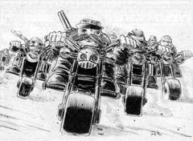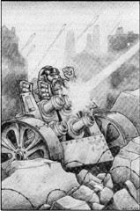

The Iron Duke

When the Tyranids attacked the Homeworlds and the last remnants of the Squat race were forced into the long Exile the Squat fleet fled into space. The captain of the Hammer class cruiser “Indomitable Will” led the rearguard. The fighting was brutal. Anvil class frigates were no match for the ripper ships of the hivemind and combat was often fought upon the decks of squat vessels as wave after wave of hormagaunts and worse assaulted the beleaguered squat crews. This brash young captain was singlehandedly responsible for destroying several hive ships, fighting into their very hearts past innumerable hordes of vicious fanged monsters to destroy the Norn Queens within. His bravery and actions saved millions of squat lives.
These victories did not come without a price however. Battle after battle, brutal bloody combat after another began to take their toll. Exhausted after yet another hive ship assault the young warrior was brutally attacked by an unseen Lictor. His body rent and torn on the creatures scything talons before his loyal deck crew gunned the beast down. Leaders and warriors of his ilk were rare, and the Squat crew loyal to their captain. They did what was necessary to save his life. Surgeons, Cyberneticists and armourers constructed a machine to keep him alive, replacing his damaged and ravaged organs with the most state of the art cybernetic devices, his strength and durability increased beyond that of mortals.
It soon became apparent that his mind however was not undamaged. The horrors of the hive fleet, the stress of the exile, the loss of the homeworlds and his own, terrible situation awoke in him a ruthless streak. Crewmembers who made mistakes were summarily executed, his enemies persecuted and burned to the last individual. No one lived to indicate the passing of the Squat fleet.
When the Imperial Sword frigate “Emperor’s Light” chanced upon his vessel, he ordered the crews to open fire without mercy. Taken by surprise the imperial ship did not stand a chance. A cloud of escape pods launched into the stars, carrying their precious human cargo to safety. He gave the order to open fire. His second in command, horrified by his order to slaughter helpless, beaten and fleeing foes refused. This action was without honour and would bring shame upon the ship’s crew. The young captain did not flinch as he snapped his closest friend’s neck and fired the cannons himself. His rule was absolute, enforced with an iron fist.
When the fleet made contact with the Tau the Iron Duke, as he had become to be known, railed against bargaining with these aliens, the Squats did not need them. They should instead take what they wanted and exterminate the Tau before they too became a threat to the Squats. When the Ancestors over-ruled him he turned his back upon them. Declaring them feeble and not worthy of the name Squat, he took his vessel and left to forge his own empire among the stars.
In these dark times when the very survival of the Squat species seems in doubt the black shape of the Hammer class cruiser “Indomitable Will” occasionally appears in orbit. It is then, when all hope seems lost that the Iron Duke will take to the field, his burning blade smiting the foes of the squats before departing back to his ship, leaving the often stunned squats wondering at this unexpected rescue. What drives him now, none can truly say. His ruthlessness and cruelty however are beyond a doubt.

Engineer Grymm
The line between insanity and genius is a very fine one. Engineer Grymm is one of the Squats most forward thinking minds. Born only 50 years ago, Grymm is very young for a Squat and considered something of a child prodigy. He has a natural affinity for machines and an ability to learn at an astonishing rate, he is almost a biological computer himself.
His genius is offset however by a detachment from reality. He lives his life half in fairytales, his own imagination a far more interesting and exciting realm than the mundane and somewhat depressing reality he has been born into. He is far too young to remember life before the exile, and to him Tyranids are “the monster under the bed” a mere horror story to make children behave.
Due to his separation from the physical world he is somewhat psychotic, little realising the effect his inventions have in the real world. His Advanced Ripper design is a brutal killing machine created for no other purpose than idle tinkering. Indeed his tendency to randomly assemble machines can be a valuable ability on the battlefield even if his concentration does wander at the most inopportune moments.

Skagg the Stealthy
The Squat known as Skagg is a veteran of the Tyranid holocaust. A skilled marksman even before the war his skills proved invaluable for targeting the larger Tyranid Synapse creatures and severing the vital connection to the hivemind. As the war raged on he became even more adept and it wasn’t long before his commander commissioned an improved long-range rifle specifically to kill these targets.
During the siege of the Iron palace the Tyranids employed swarms of flying creatures, Harridans, Harpies and multitudes of the vicious Gargoyles. Taking position in a tower Skagg began systematically targeting the larger creatures, sending them crashing to the ground in a tangle of broken chitin, however the Gargoyle swarms were unaffected by their loss and quickly closed to melee range. Skagg found himself surrounded by leathery winged creatures hissing and spitting venom. One of them found its mark, its blinding venom striking Skagg full in the face. The last thing Skagg ever saw was the mass of fanged flyers as they flew away. Abandoning him for dead now the threat of his rifle had been neutralised and moving on to other, more lethal targets.
The Squats held off the flying menace for three whole days, giving the slow moving Colossus command fortress time to evacuate the palace. Among the wounded was Skagg, his unique rifle still held firmly in his grasp.
In recognition of his bravery and sacrifice the Household Noble decreed that Skagg should be fitted with a state of the art bionic vision system. More than just the standard ocular implants these implants interface directly with the micro targeter built into Skaggs rifle giving him a direct visual on his targets and making him one of the best snipers in the galaxy
Vowing to never again be caught unawares as he was by the gargoyle attack Skagg has acquired a personal reactive camouflage suit, a much smaller version of the technology hardwired into some Squat vehicles. This unique personal disguise has earned him the nickname “Skagg the Stealthy”, an honorific he bears with great pride.

Combat Droid AA-23
The Standard procedure in most households is to give all droids, combat or otherwise, periodic mind wipes. Resetting their AI to its default parameters and eliminating any potential glitches that could creep into the system. When a droid for one reason or another manages to avoid one of these maintenance overhauls it can begin to exhibit peculiar behaviours and in extreme cases even begin to develop rudimentary personality traits.
It is unusual for a droid to avoid more than one or two of these mind wipes as the Squat attitude to machine maintenance is one of strictly adhered to procedures and carefully managed calibrations.
On the battlefields of Gehenna Terminus a Squat Land Train came under fire from heavy weapons emplacements as it moved through the rubble of a ruined city. With one of its battlecars destroyed and forced to abandon the others, the Train seemed lost. As its shields began to flicker, the crew onboard began preparations to detonate the reactor, hoping to deny the enemy their prize.
A series of explosions rocked the train, throwing crew and supplies to the floor. Hurrying to the external scope the bewildered engineers watched as missile after missile flared across the sky, each detonation signalling the demise of an enemy heavy weapon. When the explosions ceased, and the smoke finally cleared, the Chief engineer was shocked to discover the source of his salvation.
Emerging from cover came stalking a heavily armed Combat droid, moving with all the caution of a veteran warrior. This unit, designated AA-23 was the lone survivor of a Squat expeditionary force. His detachment all but wiped out, he had gone to ground. Scavenging parts from his destroyed brethren, and finding a functional rocket launcher among the dead he had repaired and re-armed himself, showing considerable resourcefulness he had survived in the ruins awaiting rescue.
The Land Train Engineers realised they owed this droid their lives and so helped the droid avoid the mind wipe procedure. This droid has since turned up in many battles, always with a slightly different battle chassis, usually carrying a heavy weapon of some description. To the Squats in his household he is a lucky charm. To others a technological curiosity they would love to study, and to others an Abomination. A sign of the end times when machines will rise up and finish the Squat race off once and for all.
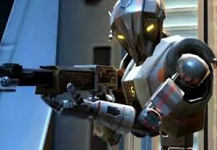

Oswynn Sevrinsdottir
Oswynn, eldest daughter of Lord Sevrin of the Mjolnir Brotherhood was an expert forcefield technician before the holocaust. When the Tyranids swarmed into the underground city-hab it was her experimental shield technology that kept the tides at bay. When her ship came under fire from elder raiders during their headlong flight through the Gothic sector it was her expert shield modulations that saved the vessel and all her crew, and when the Tau tithe worlds turned out to be dangerous irradiated balls of airless rock, it was her shields that allowed the squats to setup basic facilities and begin the long process of making them habitable.
Following the recent death of Lord Sevrin, and the ascendency of her elder brother Kalten to the throne of House Mjolnir, Oswynn has found herself the last surviving heir to the throne. It is a role she wears uncomfortably. Leadership is not her area of expertise, but the squat troops rally behind the young and beautiful princess regardless. She has become an inspirational figure to many and is greatly loved by the general populace.
Oswynn has adapted her personal protective shield generator to protect those around her, a deed which puts her royal personage at a greater risk much to the dissatisfaction of her hearthguard retainers. It is rare that she is alone on the battlefield as her loyal bodyguard and troops protect her at all costs.

The Seven Brothers
The seven brothers are a legendary mercenary band in the current employ of the Rogue Trader Cole Black. Tasked with many of the dirtiest jobs and willing to undertake any number of illegal activities for the right price, each brother is a fearsome warrior in his own right.
Their individual skills and equipment complement each other perfectly making them a fearsome unit able to achieve the nearly impossible missions the rogue trader sets for them. From infiltrating the palace of an imperial governor to demolishing the city walls of the Vansar Shipyard city, no job is beyond them.
To the Nobles of the Households the seven brothers are a black stain on the honour of the Squat race. However, when the situation is desperate and no one else can help, and assuming they can find (and afford) them, even they will hire the Seven.

Army Special Rules
A Squat Isolationist force uses several Special Rules that are common to many of its units. These are collected and explained here.

Squat:
The “Squat” special rule encompasses several other rules under one heading:
Fat of Foot: The Squats are not a particularly athletic race and coupled with their naturally short physique are not the quickest at rapid movement around the battlefield.

Squat units cannot Run.

Ancestral Grudge: The long years of war against the Orks and the predations of the Tyranids have left the Squats on the verge of extinction. They will stop at nothing to see these foes crushed underfoot.

Squat units have Preferred Enemy: Orks and Tyranids and Hatred: Tyranids

Nothing left to lose: The Squats are notoriously slow to change their minds and renowned for their surliness and intractability. Since the loss of the homeworlds this trait has come through all the stronger and Squats will fight on against impossible odds, refusing to give up even when all hope of victory seems lost.
Squat units are Stubborn.

High Tech:
Masters of technology and science the Squats have long ago perfected Plasma Technology. Squat Plasma weapons do not Get Hot.

Automaton
Many Squat units are mindless robotic constructs and therefore quite unlike living creatures. The Automaton Special rule represents this.
Automata do not have minds of their own, merely a sophisticated AI program which is easily confused and overwhelmed in chaotic battlefield situations. This can lead to instances where Combat robots have been seen to attempt to flee, or simply self destruct when faced with overwhelming enemy resistance. Luckily, Automaton units can be directly controlled by an Engineer; overriding the basic program remotely and thus become Fearless if an Engineer is within 12”.
Automaton units have no internal organs and can ignore injuries that would cripple a being of flesh and blood, continuing to function even when torn in half or partially dismembered. Automaton units have Feel No Pain 6+

Warlord Traits
When generating his warlord traits a Squat Warlord may either roll on one of the Warlord Traits tables in the main rulebook or roll on the table below:
D6 | RESULT
1 | Master of Defence: The warlord and his unit have the Counter Attack special rule while they are in their own deployment zone
2 | Immovable Object: Your Warlord is a Scoring Unit
3 | Iron Resolve: When determining assault results, add one to your total if the Warlord is locked in that combat
4 | Engineer: Your warlord has a background in Engineering and gains the engineers Repair special rule. If your Warlord is already an Engineer then he instead gains +1 to his repair rolls.
5 | Scientist: Your Warlord is an ex-scientist and has a stubborn disbelief in psychic ability. While he is alive your units may add +1 to their Deny The Witch rolls.
6 | Miner: The Warlord is a member of the Miners Guild. He and his unit gain Move through cover (ruins) and Stealth (ruins). He also has Nightvision.

Allies Matrix

Black Templars | D | Imperial Guard | A
Blood Angels | A | Necrons | D
Chaos Daemons | C | Orks | C
Chaos Space Marines | D | Sisters Of Battle | D
Dark Angels | A | Space Marines | A*
Dark Eldar | D | Space Wolves | A
Eldar | D | Tau | B
Grey Knights | D | Tyranids | C

B | Battle Brothers | A | Allies Of Convenience | D | Desperate Allies | C | Come The Apoc.

- Space Marines are classed as Allies of Convenience unless they are Ultramarines First Company (Tyranid Hunters); The Squats recognise a kindred spirit in these marines and treat them as Battle Brothers.

Squat Units:

Noble/Thane
The Isolationist forces are divided into Houses, each one ruled over by a Squat of noble birth, These mighty individuals are responsible for the continued survival of the house and act as a source of great inspiration to the warriors under their command, Oft times, when an engagement is not vitally important, these leadership duties are passed to a son or other trustworthy relative in his stead. Often armed and armoured in the most lavish and expensive equipment available to the House, the Squat nobility are an imposing sight and a very physical reminder to the troops of what they have lost and what they fight to restore.
 | WS | BS | S | T | W | I | A | LD | SV
Noble | 6 | 6 | 4 | 5 | 3 | 3 | 3 | 10 | 3+
Thane | 5 | 5 | 4 | 4 | 2 | 2 | 2 | 10 | 3+
Unit Type: Infantry (character)
Wargear: Hearthguard Armour, Ripper, Gromril Axe, Rad Grenades, Forcefield Generator
Special rules: Squat, Independent Character, Inspiring Leader.
Inspiring Leader: The Noble/Thane and the unit he joins are Fearless.

Living Ancestor
An Ancient and World weary Squat, the Ancestor is the embodiment of a House’s values and history. Often the very visionary who led the exodus; the Ancestors are not warriors, but scientists, engineers, biologists and even ship captains. These skills, combined with a will to survive and endure, have given the isolationists the closest thing to hope they possess and as a result the Ancestors are revered for their tactical acumen and strategic knowledge.
 | WS | BS | S | T | W | I | A | LD | SV
Ancestor | 4 | 4 | 3 | 4 | 2 | 2 | 2 | 10 | 3+
Unit Type: Infantry (character)
Wargear: Hearthguard Armour, Ripper, Gromril Axe, Rad Grenades, Psionic Nullifier
Special rules: Squat, Independent Character, Strategic Advisor, Master Tactician.
Strategic Advisor: The Squat army may re-deploy D3 units at the start of the game before infiltrators are placed.
Master Tactician: The Squat army may seize the initiative on a roll of 4+, In addition the Squat player may choose to add or subtract 1 from his reserve rolls.

Engineer/ Engineer Guildmaster
Responsible for maintaining and repairing the Isolationist vehicles, many Engineers are itinerant tinkerers and inventors and often take to the field of battle wielding untested weapons and armour. Being forced to cannibalize ancient technology for parts and working with crude and unrefined metals and materials they have learned to improvise far beyond the bounds of safety. This has however given them a keen understanding of technology and machinery surpassing even that of the Techpriests of Mars.
 | WS | BS | S | T | W | I | A | LD | SV
Engineer Guildmaster | 4 | 4 | 4 | 4 | 2 | 2 | 2 | 9 | 2+
Engineer | 4 | 4 | 4 | 4 | 1 | 2 | 1 | 9 | 2+
Unit Type: Infantry (character)
Wargear: Tech Suit, Ripper, Rad Grenades, Servo Arm (Guildmaster has Servo-Harness)
Special rules: Squat, Independent Character, Field Repair, Bolster Defences
Field Repair: In each of your shooting phases, instead of firing his weapons a character with this special rule may choose to repair a single friendly vehicle that he is in base contact with or embarked upon. To repair a vehicle roll a D6 and add the following modifiers where applicable:
- Each Servo-droid the character has +1
- The Character has a servo harness +1
If the result is 4 or more, you may either restore a Hull point lost earlier in the battle or repair a Weapon Destroyed or Immobilised result suffered earlier in the battle; this is effective immediately.
Bolster Defences: After Deployment, but before scout redeployments and infiltrate deployments, nominate one piece of terrain in your deployment zone (this may not be one you have purchased as part of your army). The terrain piece’s cover save is increased by one for the duration of the game (to a maximum of 3+). Note that a piece of terrain can only be bolstered once.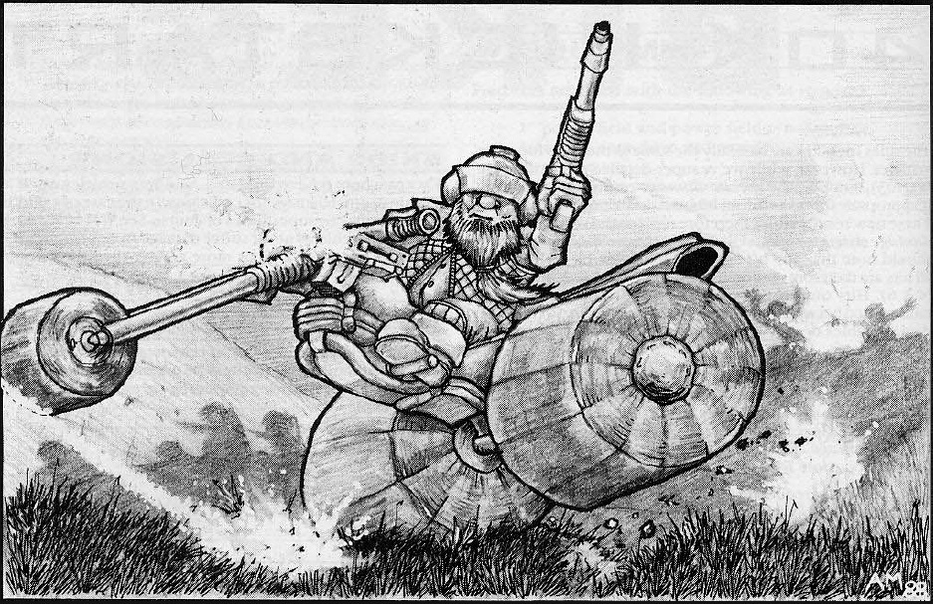

Advisory Council
The nobility are often accompanied into battle by a bodyguard of close relatives from the aristocracy of the household. These warriors are equipped with specialist equipment and often have non standard training and skills. The size of an advisory council varies from house to house and to be selected is a great honour.
The house standard is carried into battle by these warriors, each one an ancient relic steeped in history and heavy with the memories of the dead, and every Squat will fight his hardest in its presence, as losing it to the enemy or seeing it destroyed is to lose another fragment of what once was.
The Household champion is charged with defending the honour of the house. Tasked to engage the heroes of the enemy leaving the other warriors unmolested to fight on. The first into a fight, they are usually the last to leave one.
 | WS | BS | S | T | W | I | A | LD | SV
Veteran Advisor | 4 | 4 | 4 | 4 | 1 | 2 | 2 | 9 | 3+
Household Champion | 5 | 4 | 4 | 4 | 1 | 2 | 2 | 9 | 3+
Unit Type: Infantry (Household champion is Infantry (character)
Wargear:
Veteran Advisor: Hearthguard armour, Ripper, Gromril Axe, Rad Grenades
Household Champion: Hearthguard armour, Ripper, Power axe, Rad Grenades, Storm Shield
Special Rules: Squat,
Death before Dishonour: (Household Champion only) A model with this special rule must always issue and accept a challenge wherever possible
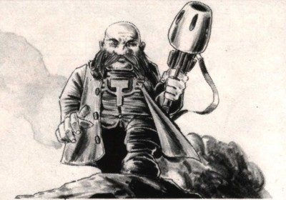

Stormragers/ Stormrage Veterans
Sometimes a Squat can be pushed too far. One too many losses, one too many compromises, one too many relics desecrated in the name of survival can cause even the most stalwart of minds to snap and the Squat in question takes up the mantle of the Stormrager. These tortured individuals have had enough, and simply wish to end it all. They are however not so selfish as to simply take their own lives as that would bring dishonour to the entire house, but rather seek death in battle against the enemies that have driven them to this point. The most (or least) successful of these Squats are the Stormrage veterans. These are mighty warriors who through sheer luck, or grim determination have proven just too tough to kill. Some are even a match for a space marine captain at close quarters!
 | WS | BS | S | T | W | I | A | LD | SV
Stormrage Veteran | 6 | 2 | 4 | 5 | 3 | 2 | 3 | 9 | 5+
Stormrager | 5 | 2 | 4 | 4 | 1 | 2 | 2 | 8 | 5+
Unit Type: Infantry. Stormrage Veteran is Infantry: Character
Wargear: Rager Harness, Two Gromril Axes (veteran has Power Axes), Frag Grenades
Special rules: Squat, Furious Charge, Rage, Fearless, Monster Hunter, Tough as Nails, Deathwish
Tough as Nails: A model with this special rule benefits from a 5+ invulnerable save and Feel No Pain (5+)
Deathwish: If a unit with this rule is still alive at the end of the game it awards 1 victory point to the opponent. If the mission awards victory points for destroying units of this type then no additional points are gained for destroying it, but an additional point is awarded to the opponent if it survives.

Hearthguard
Made up of the greatest fighters in the house, these potent warriors take to the battlefield to lead the fight to the enemy. These loyal retainers of the nobility are magnificently equipped in powered carapace armour reminiscent of archaic styles and carry a selection of specialist weaponry. Though Hearthguard do not operate as a command unit, they lead from the front and set an example of courageous conduct to the other squats.
 | WS | BS | S | T | W | I | A | LD | SV
Hearthcaptain | 4 | 4 | 4 | 4 | 1 | 2 | 2 | 9 | 3+
Hearthguard | 4 | 4 | 4 | 4 | 1 | 2 | 2 | 9 | 3+
Unit Type: Infantry. Hearthcaptain is Infantry (character)
Wargear: Hearthguard Armour, Ripper, Rad Grenades
Special rules: Squat, Fearless.

Mk II Exo Armour Suits
One of the most devastating losses in the early years of the exile was the destruction of the Exo armour suits. Often used to spearhead an assault, each suit was a priceless relic, and the pinnacle of the armour smith’s craft. Each loss diminished the entire squat race. It was only a matter of time, resources and necessity that made the creation of the new improved MkII Exo suit inevitable. More akin to Space Marine terminator armour, each suit that rolls from the production facilities turns it’s occupant into a walking behemoth.
 | WS | BS | S | T | W | I | A | LD | SV
Exo Armoured Hearthcaptain | 4 | 4 | 4 | 4 | 1 | 2 | 2 | 9 | 2+
Exo Armoured Hearthguard | 4 | 4 | 4 | 4 | 1 | 2 | 2 | 9 | 2+
Unit Type: Infantry. Exo Armoured Hearthcaptain is Infantry: Character
Wargear: MkII Exo Armour, Power Fist, Heavy Ripper
Special rules: Squat, Fearless, Relentless.

Mining Guild
Squats are natural miners and tunnel fighters. On the Homeworlds they could bore through bedrock in a matter of hours and on the Tithe worlds the Squats now inhabit, with their equally dense mantle the squats have adapted existing technology to compensate. The majority of the worlds in the Imperium are made of softer stuff, and the Squat miners can easily undermine even the most stalwart fortification. Armed with Demolition charges, Plasma Cutters and short range flamethrowers the Mining guild is a valuable asset in any noble’s household.
 | WS | BS | S | T | W | I | A | LD | SV
Foreman | 4 | 4 | 3 | 4 | 1 | 2 | 2 | 8 | 4+
Miner | 4 | 3 | 3 | 4 | 1 | 2 | 1 | 8 | 4+
Unit Type: Infantry. Foreman is Infantry: Character
Wargear: Combat Armour, Scatter Gun, Gromril Axe, Frag Grenades
Special rules: Squat, Deep Strike, Night Vision

Iron Ancestor
Very occasionally the unthinkable happens and a revered noble falls in battle. When that happens, if they can get to him in time, the surgeons and technicians of the household can artificially prolong his life. If all attempts to salvage the noble’s body fail, they will remove whatever organs are still viable and transfer his consciousness and experience into the armoured frame of an Iron Ancestor. These huge machines enable the noble to continue his existence, in a form, and means the household does not lose his experience and leadership in battle. It is by no means an ideal situation, but desperate times require desperate measures.
 | WS | BS | S | Front | Side | Rear | I | A | HP
Iron Ancestor | 4 | 4 | 5 | 12 | 12 | 10 | 2 | 2 | 3
Unit Type: Vehicle (Walker).
Wargear: Heat Hammer, Twin Linked Autocannon, Searchlight, Smoke Launchers
Special rules: Squat
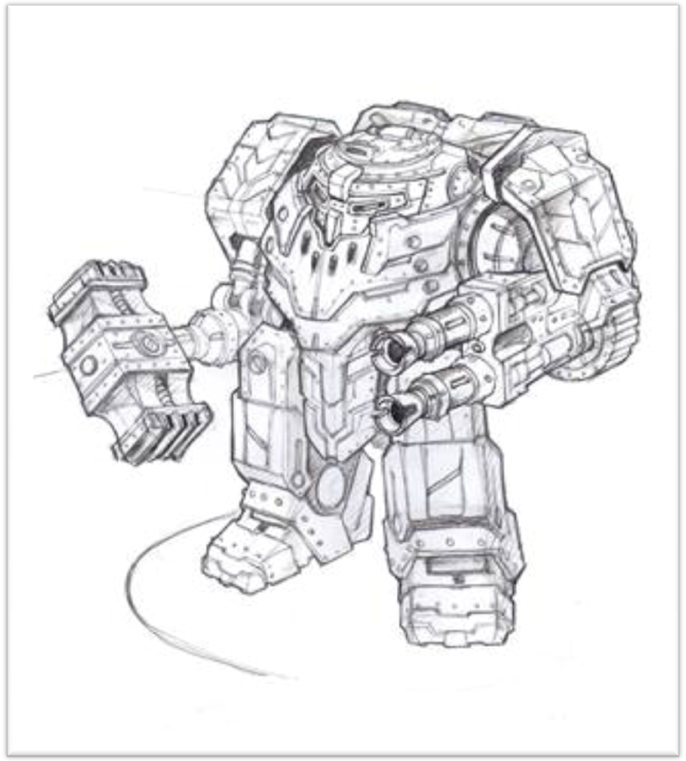

Squat Warriors
Solid and stubborn in defence and relentless in attack squats make excellent soldiers. Individual squats are highly disciplined and fiercely determined their pride and sense of honour both to the nobility and the long lost homeworlds make it impossible to be otherwise. Squats are organised into different units to fulfil specific battlefield roles according to their preferred weaponry and status within the household.
Combat Squad
Combat squads make up the bulk of a household comprising the elder members of the house’s warrior brethren; they are armed with deadly solid-slug projectile weapons with one member in five carrying a specialist or heavy weapon. A combat squad is usually led by its most senior grizzled veteran, or in some circumstances, a member of the hearthguard.
Berserkers
Berserker units are made up of the household’s most ferocious hand to hand fighters, armed with deadly axes and ripper machine pistols. All squats are doughty fighters in close combat but berserker units have faced the worst the galaxy has to offer against the most impossible odds battling fearlessly against even the mightiest of opponents without thought for their own losses.
Thunderers
Thunderers are the most heavily armed of the household units consisting of hardened warriors carrying a variety of heavy weapons. Every squat in the unit is trained to use a variety of devastating anti-infantry and anti tank weaponry with consummate skill. Thunderers supply withering support fire on the battlefield devastating concentrations of enemy troops or tanks and forming strongpoints to hold the battle line.
 | WS | BS | S | T | W | I | A | LD | SV
Squat | 4 | 3 | 3 | 4 | 1 | 2 | 1 | 8 | 4+
Squat Sergeant | 4 | 3 | 3 | 4 | 1 | 2 | 1 | 8 | 4+
Veteran Squat Sergeant | 4 | 3 | 3 | 4 | 1 | 2 | 2 | 9 | 4+
Unit Type: Infantry. Sergeant and Veteran Sergeant are Infantry: Character
Wargear:
Combat Squad: Combat Armour, Ripper, Rad Grenades
Berserker Squad: Combat Armour, Light Ripper, Gromril Axe, Frag Grenades, Krak Grenades
Thunderer Squad: Combat Armour, Ripper, Rad Grenades, Signum (Sergeant and Veteran Sergeant only)
Special rules: Squat.

Automata
Repurposed mining robots make solid if somewhat limited troops because they rely on programs which determine what they do on the battlefield rather than a warrior’s natural instincts. Despite this they have many advantages over normal troops as they are faster and do not feel pain.
Combat Droids
The Basic mining droid is a humanoid chassis of varying design, with ablative derma-armour and a limited AI program. Armed with the standard squat Autorifle they are individually weak but can be devastating in large numbers. Each Robot unit can be accompanied by a dedicated Robotician who will assume direct control on the field and increase performance tenfold. The other notable feature of these droids is their compactability, each droid can fold into a cube for transport saving space and deploying in large numbers in the heart of enemy formations
 | WS | BS | S | T | W | I | A | LD | SV
Combat Droids | 2 | 2 | 3 | 3 | 1 | 3 | 1 | 5 | 5+
Unit Type: Infantry.
Wargear: Battle Chassis, Ripper.
Special rules: Automaton.
Survey Drone
The Light Survey drone is an all-terrain droid designed to seek out mineral concentrations and take samples, varying in design, some are spiderlike crawlers, and others hover above the ground or have tracks. Each survey drone has sophisticated sensors and an interpretive AI program. This makes them excellent battlefield scouts.
 | WS | BS | S | F | S | R | I | A | HP
Survey Drone | 3 | 3 | 5 | 10 | 10 | 10 | 3 | 1 | 2
Unit Type: Vehicle (Walker)
Wargear: Heavy Bolter, Refractive Camouflage, Sensor Array
Special rules: Automaton, Scout, Move Through Cover

Heavy Mining Droid
The largest obstructions require less finesse and more brute force. This is where the Heavy Droid comes into play. Towering beetle-like behemoths equipped with heavy plasma cutters and enormous powered lifting claws these robots have little to no AI but are tough as the rocks they were designed to move. The increased energy cell fitted in these droids means that they are easily adaptable to carry many different types of additional energy weapon and makes them a valuable support resource.
 | WS | BS | S | T | W | I | A | LD | SV
Heavy Mining Droid | 4 | 3 | 8 | 8 | 3 | 3 | 3 | 5 | 3+
Unit Type: Monstrous Creature (character)
Wargear: Heavy Plasma Cutter
Special rules: Automaton.
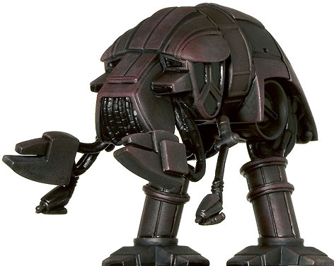

Artillery
Thudd Gun
The Thudd gun is a medium artillery piece that fires high explosive shells. It shoots rapidly, its multiple barrels pumping in and out with a distinctive ‘thud thud’ noise, hence the common name of “thudd gun”. The thudd gun is mounted on a mobile track unit but once deployed rarely moves as befitting a defensive cannon.
Mole Mortar
The mole mortar was actually developed by the Squats to overcome the problems of fighting underground on the barren rocky homeworlds. The mortar has a crew of two Squats who can dismantle and move the machine if necessary. The mortar fires a burrowing shell called a tunnel torpedo. This self guided projectile travels rapidly underground before travelling up to the surface and exploding beneath the target. This causes the ground to collapse beneath the target engulfing infantry or tanks and sometimes even trapping them in place.
Heavy Mining Laser
An adaptation of the large industrial lasers used to carve through solid rock the mining laser shares the same tracked chassis as the thudd gun but is similarly immobile once deployed. The heavy mining laser uses micro fuel cells to produce a coherent beam of light which is focussed through a crystal array, this arrangement allows for an adjustable beam suitable for varying minerals and ore mining operations. Such a device, when turned upon living beings leaves few remains.
Thunderfire Cannon
Due to the perpetual smoke and ash clouds which cloak the Tithe worlds in perpetual darkness, the Squat Air corps has been largely disbanded. Very few of the old Gyrocopters are air-worthy, and those few that do operate are rickety old relics which are vastly outclassed by the flying vehicles of other races. The Squats quickly realised that they needed a reliable way to counter the airborne threat and so developed the Thunderfire anti-air cannon. Equipped with the very latest in smart tracking systems, the Thunderfire is capable of laying down a withering storm of flak.
 | WS | BS | S | T | W | I | A | LD | SV
Squat Crew | 4 | 3 | 3 | 4 | 1 | 2 | 1 | 8 | 4+
Artillery Piece | - | - | - | 7 | 2 | - | - | - | 3+
Unit Type: Artillery. Mole Mortar batteries are Infantry
Wargear:
Squat Crew: Combat Armour, Ripper.
Special rules: Squat, Artillery.

Motor Pool
Bike
Squats used to use bikes and small Trikes extensively for personal transportation across the bleak wastelands of the Homeworlds; there is something about roaring around at high speed that appeals to a part of the Squat psyche. It was only natural that they would mount weapon systems onto their vehicles and take them out to the battlefield! The Engineers guild has always been most renowned of all for its love of these particular machines and used to field entire squadrons of bikes and Trikes in support of the warrior brotherhoods. Since the exile, the exuberance of the Squats has been largely blunted and Bikes stripped for spares and components but there are still those few who just cannot bear to let a good thing go...
Trike
The Guild Trike is used exclusively by the Engineers guild. It is a large reinforced trike which used to carry a driver and a gunner (now replaced with an AI targeting system) and mounts a suitably imposing heavy weapons system on the back of the speedy light vehicle. Guild trikes are renowned for their fearless leaps and daredevil skid turns evading enemy fire as they make hit and run attacks on enemy vehicles with stunning bravado
 | WS | BS | S | T | W | I | A | LD | SV
Bike | 4 | 3 | 3 | 5 | 1 | 2 | 1 | 8 | 4+
Hearthguard Biker | 4 | 4 | 4 | 5 | 1 | 2 | 2 | 9 | 3+
Trike | 4 | 3 | 3 | 5 | 2 | 2 | 2 | 8 | 4+
Unit Type: Bike. Hearthguard Bikers are Bike (character)
Wargear:
Hearthguard: Hearthguard armour, Ripper, Frag Grenades, Krak Grenades.
Bike/Trike: Combat armour, Ripper, Frag Grenades, Krak Grenades, Squat Bike or Trike.
Special rules: Squat.
Quad
The inhospitable environment and even more rugged terrain of the Tithe world has led to the development of the enclosed Quad. Sturdier and more robust than a bike or trike these vehicles are still able to keep up with their more exposed brethren with the added benefit of being able to mount even more powerful weapons. One such weapon system is the Deathwind missile launcher, making the Quads into a fearsome mobile support firebase.
 | BS | F | S | R | HP
Quad | 3 | 10 | 10 | 10 | 2
Unit Type: Vehicle (Fast)
Wargear: Twin Linked Ripper
Special rules: Jink
Iron Grumbler
The Rhino APC is the most widely used transport vehicle in the Imperium and many thousands were traded to the Squats. Over the years in exile the Squat engineers have completely reverse-engineered the rhino down to its bare chassis, Stripped out all the unnecessary systems and rebuilt from the ground up. Part of this retrofit was the addition of a rudimentary AI system to replace the archaic onboard computer systems used by the Imperium. For some reason the AI core in the Rhino chassis always seems to become intractable and surly within a matter of days and has given these rebuilt Rhinos the affectionate nickname of “Iron Grumblers”
 | BS | F | S | R | HP
Iron Grumbler | 4 | 11 | 11 | 10 | 3
Unit Type: Vehicle (Tank, Transport)
Wargear: Twin Linked Ripper, Searchlight, Smoke Launchers
Special rules:
Repair: If an Iron Grumbler is Immobilised, then in subsequent turns it may attempt to repair itself instead of shooting. To make the attempt roll a D6 in the shooting phase; on a roll of a 6 the vehicle is no longer immobilised. Note that a successful repair does not restore a Hull Point.
Transport:
Transport Capacity: Twelve models. It cannot carry models with the Bulky, Very Bulky or Extremely Bulky special rules.
Fire Points: Two models may fire from the Grumbler’s top hatch.
Access points: The Grumbler has one access point on each side of the hull and one at the rear.
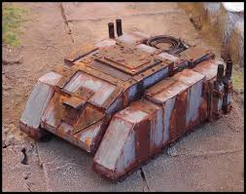
Ore Hauler
These utilitarian vehicles are lightly armed and heavily armoured, but have a large internal cargo space used for transporting ore, precious stones and mining droids to and from dig sites. Their simple tracked design allows them to negotiate a variety of terrain with ease delivering their precious payload whatever the odds. On the battlefield these vehicles are used to transport a cargo of modified combat droids deploying them where needed.
 | BS | F | S | R | HP
Ore Hauler | 3 | 13 | 12 | 10 | 3
Unit Type: Vehicle (Tank, Transport)
Wargear: Heavy Ripper, Searchlight, Smoke Launchers
Special rules:
Transport:
Transport Capacity: Fifteen models. It cannot carry models with the Very Bulky or Extremely Bulky special rules.
Fire Points: Two models may fire from the Hauler’s top hatch.
Access points: The Hauler has one access point on the front.
Droid Racks: The Ore Hauler may transport up to 30 combat droids.
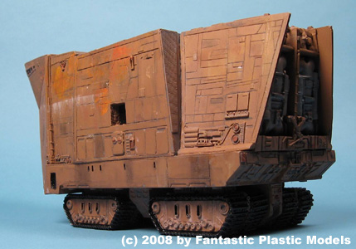
Termite
The Termite is the smallest of the tunnelling transport torpedoes utilised by the Squats. These mining machines tunnel their way underground while the battle rages above, bypassing enemy troops and fortifications and emerging behind their lines. Squats appreciate the value of tunnellers as assault vehicles for overcoming both surface defences and subterranean strongholds.
 | BS | F | S | R | HP
Termite | 4 | 12 | 12 | 12 | 3
Unit Type: Vehicle (Tank, Transport)
Wargear: Heavy Ripper, Searchlight, Smoke Launchers
Special rules: Tunneller
Transport:
Transport Capacity: Twelve models. It cannot carry models with the Bulky, Very Bulky or Extremely Bulky special rules.
Fire Points: None.
Access points: The Termite has one access point on each side of the hull.
Tunneller: This unit enters play by Deep Strike. When declaring the target point for Deep striking, you may purposely target an enemy unit and try to surface underneath them. Place the Large Blast marker on the target point and roll for scatter as normal. Any models touched by the large blast marker take a S6 hit with AP2. Move any surviving models to the edge of the blast marker. Any model that cannot move out of the way is removed as a casualty, and then replace the Large Blast marker with the Termite model. Any unit forced to move in this way must take a pinning test.
The Termite may re-submerge in the following turn’s movement phase and enters ongoing reserves.

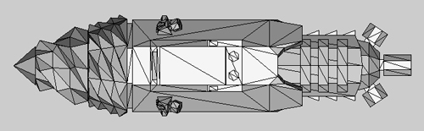

Land Train
The largest vehicle used on a regular basis by Squat forces, the Land Train is a smaller version of the gigantic crawlers used on the homeworlds. The engine itself is well armoured and carries a devastating selection of heavy ordnance to pulverise the foe, and boasts a miniaturised Void shield generator. Each additional battlecar brings its own fusion reactor and unique armament and the increased power capacity boosts the shield generators even further making the Land train a mobile fortress more than capable of engaging and destroying enemy armour and infantry with ease.
Berserker Battlecar
The berserker battlecar is a basic hull module armed with a single point defence Heavy Ripper. The true value comes in its ability to safely transport troops across the battlefield and deliver them to the fight unscathed.
Mortar Battlecar
The Mortar battlecar mounts a large bore barrage weapon called a Siege Mortar. The Siege Mortar fires heavy shells capable of bursting apart heavy tanks or bringing buildings crashing down into rubble. A similar weapon is used by the Imperial Guard but the Land Train mounted weapon benefits from more accurate calibration and a greater stock of shells.
Dragon Battlecar
The Dragon battlecar carries a large very heavy flamethrower, a particularly useful weapon for tunnel fighting and for use in built up areas where the torrent of flames can burn out enemy infantry from side tunnels and buildings with ease
Bomb Battlecar
Bomb battlecars carry a single large missile armed with a high yield rad bomb. This is a one-shot missile which is particularly useful for clearing concentrations of enemy forces in woods or buildings as the powerful radiation pulse generated by the warhead passes straight through cover
Hydra Battlecar
The Hydra battlecar mounts an independently targeting anti-air cannon designed to neutralise enemy flyers before they become a threat. The gun is pivot mounted and controlled entirely by its onboard AI and can target independently.
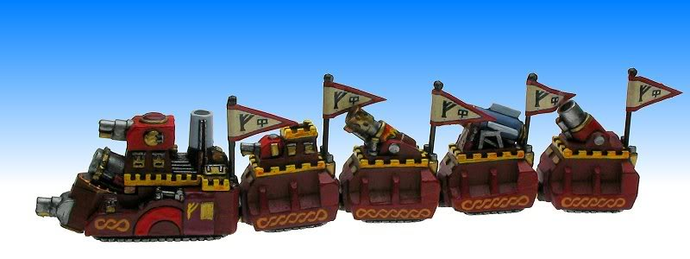
 | BS | F | S | R | HP
Land Train Engine | 4 | 14 | 13 | 11 | 4
Land Train Battlecar | 4 | 10 | 12 | 10 | 3
Unit Type: Heavy Vehicle (Tank), Berserker Battlecar is Vehicle (Tank, Transport)
Wargear:
Engine: Battlecannon, Exterminator Autocannon, Heavy Ripper, Forceshield Generator, Dozer Blade, Searchlight, Smoke Launcher.
Berserker Battlecar: Heavy Ripper, Shield Booster.
Mortar Battlecar: Heavy Mortar, Shield Booster.
Dragon Battlecar: Inferno Cannon, Shield Booster.
Bomb Battlecar: Rad Bomb, Shield Booster.
Hydra Battlecar: Thunderfire Cannon, Shield Booster.
Special rules:
Engine:
Land Train: The Land Train and battlecars form a single model on the battlefield and may not move separately, each Battlecar must link its front facing to the rear facing of either another battlecar or the land train engine at all times. However, the Engine and battlecars count as separate models for the purposes of shooting, damage, close combat etc. If one of the Battlecars is destroyed the remaining Train components must link up in the next Squat movement phase. If the Engine is destroyed the whole Land Train will be immobilised for the rest of the game.
Behemoth: The Land train may always fire all its weapons at its full Ballistic Skill, regardless of how far it has moved in a turn, however it has a maximum speed of 6”+D6” (roll each time it moves)

Berserker Battlecar:
Transport Capacity: Twelve models. It may not carry models with the Very Bulky or Extremely Bulky special rules.
Fire points: Two on the roof and two on each side facing.
Access Points: One on each side.
Mortar Battlecar: Accurate Bombardment: When the Battlecar fires the controlling player may re-roll the scatter dice if he wishes
Dragon Battlecar: None
Bomb Battlecar: One Shot Weapon
Hydra Battlecar: None
Squat Armoury

Ranged Weapons
Squats still make use of certain Imperial technologies. The rules for the following weapons can be found in the 40k rulebook:
- Boltgun Flamer Plasma Pistol
- Heavy Bolter Heavy Flamer Plasma Gun
- Autocannon MeltaGun Plasma Cannon
- Battle Cannon Multi Melta Missile Launcher
- Lascannon Demolition Charge

Rippers
Years of fighting Orks and Tyranids has led to the creation of a family of weapons colloquially known as “Rippers”. These solid-shot weapons use ammunition mined from the highly irradiated rock of the tithe worlds accelerated to near light speeds by Railgun technology to literally rip a target apart with sheer volume of fire. The Squats make use of available materials and so often these weapons are re-housed in old Lasgun or Autogun casings meaning a Squat weapon may not be quite what it looks like....
WEAPON | R | S | AP | SPECIAL
Light Ripper | 12 | 3 | - | Assault 2, Shred, Counts as a pistol in hand to hand.
Ripper | 18 | 4 | - | Assault 3, Shred
Heavy Ripper | 24 | 5 | - | Salvo 3 / 5, Shred
Ripper Minigun | 24 | 6 | - | Heavy 4, Shred, Rending

Scatter Gun
The Squat Scatter Gun is a large bore weapon much like a shotgun which fires a wide spread of irradiated pellets. Enemies at close range are more likely to be hit by more of the blast and therefore the weapon has two profiles
WEAPON | R | S | AP | SPECIAL
Scatter Gun (Close) | 6 | 5 | 4 | Assault 2, Shred.
Scatter Gun (Long) | 12 | 4 | 6 | Assault 2

Plasma Cutters
The Squat Mining Guild make use of Plasma based cutting tools to hew through the solid rock of the Tithe worlds, these weapons can be devastating when turned on a living target.
WEAPON | R | S | AP | SPECIAL
Plasma Cutter | 12 | 6 | 2 | Assault 2, Counts as a pistol in hand to hand.
Heavy Plasma Cutter | 18 | 6 | 2 | Assault 3,

Mining Laser
When an obstruction proves too large for the Plasma Cutter, the Squat Heavy mining droids can be fitted with an industrial mining laser. This tool is designed to carve gargantuan rocks down to more manageable sizes for easier removal by the mining crew. It is equally effective at carving enemy vehicles.
WEAPON | R | S | AP | SPECIAL
Mining Laser | 36 | 8 | 2 | Heavy 1, Lance

Light Missile Pod
The Quad can eschew its usual Twin linked Ripper armament in favour of a Light Missile pod. This close support system suits the Quad’s Hit-and-run mentality, while providing some much needed mobile close-range crowd control
WEAPON | R | S | AP | SPECIAL
Light Missile Pod | 12 | 5 | - | Heavy 1, Large Blast

Grav-Weaponry
Unlike the Adeptus Astartes, the Squats make widespread use of Graviton Technology, one of the races’ most basic sciences. In battle, Grav-weapons affect the local gravity field, using their victim’s own mass against them, an ordeal that will stun those it does not kill outright.
WEAPON | R | S | AP | SPECIAL
Grav Pistol | 12 | * | 2 | Pistol, Concussive, Graviton
Grav Gun | 18 | * | 2 | Salvo 2 / 3, Concussive, Graviton
Grav Cannon | 24 | 5 | - | Salvo 3 / 5, Concussive, Graviton
Graviton: The roll needed to wound when firing a graviton weapon is always equal to the armour save of the target to a minimum of 6+. When resolving a hit against a vehicle roll a D6 for each hit instead of rolling for armour penetration. On a 1-5 nothing happens. On a 6, the target is immobilised and loses a single hull point. Grav weapons have no effect on buildings.

Conversion Beamer
Conversion Beam projectors fire a beam that induces a controlled subatomic reaction in the target converting mass into energy. The further away the target, the more deadly the blast as the beam has time to grow in power. A shot from a conversion beamer has a different profile depending on how far away the firer is from the target.
WEAPON | R | S | AP | SPECIAL
Up to 18” | 18 | 6 | - | Heavy 1, Blast.
18”-42” | 42 | 8 | 4 | Heavy 1, Blast.
42”-72” | 72 | 10 | 1 | Heavy 1, Blast.

Heavy Mining Laser
The Heavy Mining Laser is deployed as a static artillery piece in times of war. The adjustable crystal focus allows the weapon to be fired in a variety of modes from a narrow beam to a wider blast which devastates a much broader area.
WEAPON | R | S | AP | SPECIAL
Dispersed | 60 | 5 | 6 | Heavy 1, Large Blast
Focussed | 60 | 7 | 4 | Heavy 1, Blast
Lance | 60 | 9 | 2 | Heavy 1, Lance

Thudd Gun
The Thudd gun is the most iconic of the squat artillery pieces, used since the age of strife, now modified to fire the same radioactive shells as the Ripper, only much, much larger and more destructive.
WEAPON | R | S | AP | SPECIAL
Thudd Gun | 60 | 6 | 5 | Heavy 4, Barrage, Blast.

Mole Mortar
The mole mortar is usually deployed in batteries, each tunnel torpedo linked to the others so they all emerge and detonate under the same target. A single tunnel torpedo is bad enough, but everything counts in large amounts!
WEAPON | R | S | AP | SPECIAL
Mole Mortar | 60 | 4 | - | Heavy 1,Barrage, Blast, Tremor
Tremor: Any unit hit by a Mole Mortar will move as if in Difficult Terrain in its following movement phase. If the unit is moving through difficult terrain anyway, it rolls one less dice than normal (to a minimum of one) to determine its maximum move. A vehicle must instead take a Dangerous Terrain test if it moves in the following movement phase.

Thunderfire Cannon
Used both as an individual Artillery piece and as the armament on a Hydra Battlecar, the Thunderfire cannon is the Squat answer to enemy flyers. Having no air force of their own the Squats are free to fill the sky with irradiated debris indiscriminately, regardless of the long term damage this may cause.
WEAPON | R | S | AP | SPECIAL
Thunderfire Cannon | 48 | 7 | 4 | Heavy 4, Interceptor, Twin Linked, Skyfire.

Exterminator Autocannon
The Secondary armament of the Land train, the Exterminator is designed to deal with light vehicles and heavy infantry who may have made their way inside the protective forceshield. The Exterminator system is still in use by the Imperial Guard, but as the main armament on one of their many Leman Russ variants
WEAPON | R | S | AP | SPECIAL
Exterminator | 48 | 7 | 4 | Heavy 4, Twin Linked.

Heavy Mortar:
The Mortar Battlecar is designed for close to medium range fire support, and can achieve a surprisingly accurate bombardment. Its weakness lies in the fact that the mortar cannot aim at point blank targets, rendering it effectively useless should enemies manage to close to that range.
WEAPON | R | S | AP | SPECIAL
Heavy Mortar | 12-48 | 6 | 4 | Ordnance Barrage 1, Large Blast.

Inferno Cannon:
The Dragon Battlecar is the Land Train’s primary method for dealing with enemies at point blank range. The deadly Inferno Cannon is a fearsome weapon indeed and many foes would rather face the wrath of the Landtrain’s other weapon systems than give this weapon a chance to target them.
WEAPON | R | S | AP | SPECIAL
Inferno Cannon | T | 6 | 4 | Heavy 1, Torrent, Ignores Cover.

Rad Bomb:
The Bomb Battlecar exists to serve one purpose; to deliver a Tactical Nuclear strike into the heart of the enemy formation. The Bomb Battlecar is a primitive and dirty weapon and can leave entire areas irradiated for hundreds of years. Few weapons unleash the same destruction as the Rad Bomb.
WEAPON | R | S | AP | SPECIAL
Rad Bomb | 12-960 | 10 | 1 | Ordnance Barrage, One Shot only, D3+3” Blast. Ignores Cover, Rad.
Rad: Due to the EMP pulse generated by the detonation of the Rad bomb the full strength of 10 is always used for armour penetration.

Melee Weapons
Squats still make use of certain Imperial technologies. The rules for the following weapons can be found in the 40k rulebook:
- Chainfist
- Lightning Claw
- Power Fist
- Power Axe

Gromril Axe:
The Standard close combat weapon of the Squat warrior, the Gromril Axe is a highly decorated and ornate instrument of death. Each one is handed down through generations and is maintained and looked after as a physical link to what has been lost. No two axes are exactly alike and to the trained observer are as distinctive as squad markings in other armies.
WEAPON | R | S | AP | SPECIAL
Gromril Axe | - | +1 | 5 | Melee, Unwieldy

Heat Hammer:
Glowing red hot from its internal generator the Heat Hammer releases a tremendous blast of energy when swung, slamming the foe to the ground and leaving him stunned and burned. This combined with the crushing weight of the weapon itself makes for an incredibly deadly weapon. In the hands of a skilled user this blast of heat can be directed towards an enemy at range although doing so drains the fuel cell temporarily.
WEAPON | R | S | AP | SPECIAL
Heat Hammer | - | X2 | 2 | Melee. Concussive, Unwieldy, Specialist Weapon, Heat Blast
Heat Blast: Once per game the Heat hammer may be fired as a Melta Gun. If this ability is used however, for the next turn the Hammer loses the Concussive special rule and becomes AP-

Servo Arm:
Squat Engineers are equipped with powerful servo arms that can be used for battlefield repairs or even put to use as weapons.
WEAPON | R | S | AP | SPECIAL
Servo Arm | - | X2 | 1 | Melee, Unwieldy, Specialist Weapon,

Armour

Battle Chassis:
Combat droids come in all shapes and sizes. The two things they have in common are a Basic AI program and an armoured metal body. Since the Robots vary in size and shape so wildly between households their armoured skin is merely referred to as a Battle Chassis. Models Equipped with a Battle Chassis receive a 5+ Armour Save

Rager Harness:
The Stormragers eschew conventional armour preferring to face their foes bare chested and primal. This is not particularly useful for carrying grenades or other essentials however and so many Ragers will often don a simple harness or bandolier. This, combined with the Ragers natural toughness confers a 6+ Armour Save
Combat Armour: Squats utilize a variety of armour types and designs, from the High-Tech armoured plates of House Mantic, to the more traditional flak jacket and combat helmet still worn by some combat squads. The design of Squat armour is as individual as the Squat himself and varies from household to household. Regardless of its appearance Squat Combat Armour provides excellent protection and confers a 4+ Armour Save
Hearthguard Armour: The Hearthguard of each House are equipped with the finest armour and weapons in the Squat armoury. Usually these semi-powered armour suits are finely crafted heirlooms, maintained to the highest standards and meticulously repaired of battle damage and dirt after each engagement. Earning the armour of the Hearthguard is one of the greatest honours a Squat can hope for. Hearthguard Armour provides a 3+ Armour Save
MkII Exo Suit: The MkII Exo suit is the pinnacle of Squat personal armour technology, reserved exclusively for the nobility and their immediate households, each suit contains numerous backup systems, Gyro stabilised weapon hard points and a personal forcefield generator. Squat MkII Exo-Armour provides a 2+ Armour Save and a 5+ Invulnerable Save
Tech Suit: The members of the Engineers Guild continually strive to improve Squat technology to the point where they can begin to make the Tithe worlds habitable and are itinerant tinkerers, never more so than on their own weapons and armour. The many experimental upgrades vary from engineer to engineer but in general an experimental Tech Suit grants a 2+ Armour Save
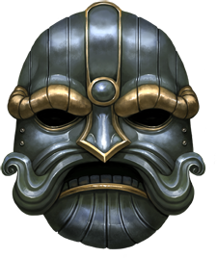

Wargear
Squats still make use of certain Imperial technologies. The rules for the following equipment can be found in the 40k rulebook:
- Frag Grenades
- Krak Grenades
- Melta Bombs
- Rad Grenades (count as Defensive Grenades)
Psionic Nullifier:
Developed as a counter to the Ork Weirdboyz and Tyranid monstrosities, the Psionic Nullifier utilises a crystal matrix to sever connections to the warp in the local area.
Each time a unit (or model) is targeted by an enemy psychic power and is within 6” of a friendly model with a Psionic Nullifier, the model with the nullifier may attempt to Deny The Witch in their stead, as if they were in that unit and receive a +1 modifier. If the Deny The Witch roll is failed, the psychic power is resolved as normal, but affects only the initial target, not the bearer of the Nullifier. If embarked on a vehicle the Nullifier can be used to protect the vehicle it is embarked upon
Forcefield Generator:
A belt mounted generator which produces an energy field that wards against even the most potent enemy weapons A Forcefield Generator confers a 4+ Invulnerable Save
Storm Shield:
A Storm Shield is a large solid shield that has an energy field generator built into it. Though the bulk of the shield offers physical protection, it is the energy field which is truly impressive-famously capable of deflecting almost any attack. Even blows that would normally cut through Exo Armour are turned aside with ease by the protective energies of the storm shield.
A Storm Shield confers a 3+ Invulnerable Save. In addition, a model equipped with a Storm Shield can never claim the +1 Attack bonus gained for being armed with two Melee weapons in an assault.
Servo Harness:
This Backpack mounted contraption is a mobile tech workshop. It incorporates many tools, mechanical limbs and weapons, all of which enable an Engineer in the field to make battlefield repairs to vehicles, shore up defences, or to assist his household in combat.
A servo-harness gives the bearer an extra servo arm, a Plasma Cutter, and a Flamer. In the shooting phase, the bearer can fire both harness-mounted weapons, or one harness-mounted weapon and another weapon.
Servo droid: A servo droid is a simple mechanical assistant to a Squat Engineer. These small and weak robots are ineffective in battle and as such have no separate profile of their own. Each Servo-droid does however grant a +1 Modifier to an Engineer’s Field Repair rolls

Bike:
Squat Bikes are fitted with powerful engines, armour plating and onboard weapon systems capable of accurate fire even at high speeds. The small stature of the Squat rider, coupled with the Bike’s rugged construction make bikers surprisingly tough.
Models equipped with a Squat Bike change their unit type to Bike, as described in the main rulebook. Squat Bikes are fitted with Twin-linked Boltguns.
Trike:
The Squat Trike is a formidable mobile firebase, with twin-linked bolters bolstered by a heavier armament operated and powered by a dedicated AI removing the need for a separate gunner.
A model equipped with a Trike change their unit type to Bike, as described in the main rulebook. Trikes are fitted with Twin linked Boltguns and a Heavy Ripper.
Bionic Arm:
The Tithe worlds are a hostile environment and injury is common. Loss of a limb is crippling in the short term, but can be a blessing in disguise as the Squat surgeons and cyberneticists are extremely skilled and often the replacement limb is far superior to the lost body part.
A model with one or more Bionic Limbs adds +1 to his Strength value.

Bionic Eye:
A bionic eye often incorporates multi-spectrum visualisers, long range image enhancement and a target recognition and acquisition algorithm. Bionic eyes are difficult to produce and highly prized. Each one has to be specifically made and calibrated precisely for the user.
A model with a Bionic Eye adds +1 to his Ballistic Skill value.
Steel Skull:
Squats have naturally heavy skeletons and thick skulls and can withstand head trauma that would kill or incapacitate most other races. Sometimes even horrific injuries can be repaired and the bone replaced with solid steel or in extreme cases, Gromril armour plating.
A model with a Steel Skull adds +1 to his Toughness value but reduces his Leadership by -1
Organ Augmetic Implants:
Artificial hearts, lungs and other organs have been in use for millennia and the Squats make extensive use as their own internal organs and soft tissues degrade rapidly in the harsh irradiated environments of the Tithe worlds. These cybernetic internal organ transplants have the added benefit of being resistant to small arms fire and are less easily damaged in combat by concussive forces.
A model with Organ Augmetics gains the Feel No Pain (5+) Special Rule

Household Standard
A Household Standard is a revered and treasured relic of the homeworlds. Each has seen action on countless battlefields and is an inspiration to the squats which fight under it. Any one of them would gladly give his life to protect it as it is the Household’s honour made tangible.
Friendly Squat units within 12” of the bearer of the Household Standard re-roll failed morale and pinning tests. In addition all friendly Squat models in the same unit as this banner have +1 Attack while the bearer is alive.

Medi Kit
a small first aid kit that contains limited-utility diagnosis equipment and other essential medicines for the treatment of minor wounds, this compact package is designed to provide a trained medic with the tools necessary for field care, yet also allowed untrained users to provide emergency medical assistance if the need arises.
As long as the Medic is alive, all models in his unit have the Feel No Pain special rule.
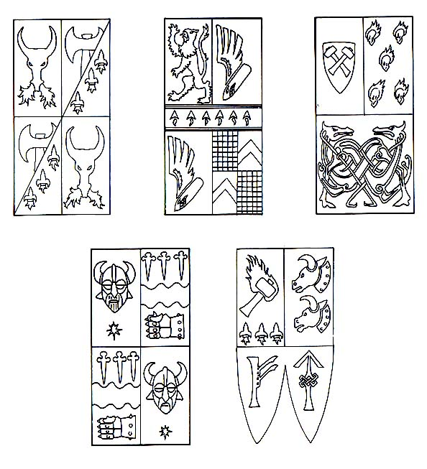

Runic Items

Forgefather’s Hammer:
This enormous 2 handed hammer has seen countless battles against the Tyranid and Ork hordes and dates back to the fields of Golgotha Prime. Made from a solid chunk of precious Gromril and tempered in the heart of the first world furnace the Forgefather’s Hammer is rumoured to have once belonged to Grungni, the Squat deity of the forge. It is carved with undecipherable ancient runes which glow orange and pulse with the heartbeat of the squat who carries it.
WEAPON | R | S | AP | SPECIAL
Forgefather’s Hammer | - | 10 | 1 | Melee, Unwieldy, Two Handed, Concussive, Master Crafted.

Demiurg Armour:
Squat Starforge class starships made up the bulk of the exile fleet as they fled across the galaxy. Rarely if ever sighted outside the home systems before the Tyranid holocaust, Imperial ship captains failed to recognise these vessels and gave them the designation of “Demiurg”. The Demiurg Armour is in fact a sub class of Exo Armour used by ship crews for EVA operations. It incorporates high powered booster jets and advanced life support systems for deep space operations.
The Demiurg Armour confers a 2+ Saving Throw and a 5+ Invulnerable Save. It also grants the Eternal Warrior special rule. Finally, a model wearing Demiurg armour is type: Jet Pack Infantry.

Fell Axe:
The Fell Axe belonged to the revered Ancestor Fell, the designer responsible for many of the Squat vehicles in use today. In his youth Fell single handedly re-engineered the Termite, removing many extraneous systems and improving efficiency of the drill head by 120%. During the Tyranid holocaust Fell defended his Forge workshop against impossible odds sending wave after wave of the Alien hordes to their doom. After the battle of the Ramshackle hills he was declared MIA and his eventual fate remains unknown, his legendary axe was recovered from the carcass of a Bio-Titan and remains a valued heirloom of the entire Squat race.
WEAPON | R | S | AP | SPECIAL
Fell Axe | - | +1 | 2 | Melee, Unwieldy, Armourbane, Fleshbane.

Tankard of Halon:
Renowned for his enormous appetite and equally enormous girth, Lord Halon of house Mjolnir was an influential diplomat and liaison with the Imperium during the Tyranid wars. His negotiation skills led to many alliances throughout the conflict and saved billions of Squat lives over the course of the war. Some say his ability to charm and beguile his peers was due to sheer charisma, others point to the Jewel encrusted runic goblet he took with him wherever he went. His bartering and shrewd bargaining have left many imperial worlds indebted to the Squats. Debts they may yet have to collect upon.
The tankard of Halon makes the warrior carrying it Fearless. In addition, if the Squat army includes any Allies, treat them as being Battle Brothers for all intents and purposes.
Grudge Settler:
The Grudge Settler is a heavy rifle of unknown manufacture. It operates from a fusion fuel cell firing single bolts of crackling green energy over long distances which explode upon impact. The recoil from such a destructive weapon is such that the firer often ends up on his back in the dirt, meaning even if his shot misses, one way or another, his grudge is likely to be settled.
WEAPON | R | S | AP | SPECIAL
Grudge Settler | 24 | 7 | 4 | Heavy 1, Large Blast, Rending

Codex Of Rasmus:
Written by the revered Ancestor Rasmus, this book is the last surviving record of the glory days of the Squat Empire which at its apex spanned a thousand worlds. Within its hallowed pages are details of day to day life on the homeworlds alongside shrewd military advice, tactical formations and technical schematics. The presence of the book is inspirational to the Squats and they will fight all the fiercer in its presence
Squat units within 12” of the Codex are Fearless and gain the Counter Assault and Rampage Special Rules.
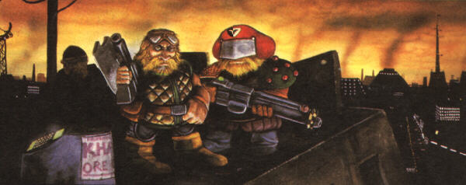

Vehicle Upgrades
Rules for the following upgrades can be found in the main 40k rulebook.
- Extra Armour
- Dozer Blade
- Searchlight
- Smoke Launchers
Ceramite Plating:
Reinforced hull plating imbued with various heat and radiation dissipating materials this has the effect of rendering certain weapons next to useless as well as protecting the crew from the harshest environments the Tithe worlds can offer.
Melta weapons do not roll an extra D6 armour penetration when shooting this vehicle at half range or less.
Onboard AI Processor:
The Squats reliance on Artificial Intelligence even extends to making their vehicles self-aware. Particularly old vehicles develop personalities of their own and will sometimes refuse to start or even display traits of self-preservation when threatened.
In a turn in which the vehicle neither moves flat out or uses smoke launchers, the vehicle can fire one more weapon at its full Ballistic Skill than normally permitted. In addition this weapon can be fired at a different target unit to any other weapons, subject to the normal rules for shooting.
Refractive Camouflage:
Using sophisticated imaging and holographic projection equipment this vehicle can become virtually invisible. Due to the way the image is recorded and reproduced, the faster the vehicle moves the less effective this camouflage becomes as the image becomes distorted and easy to spot.
Vehicle move this turn: | Camouflage Effect
Stationary | Shrouded
Combat speed | Stealth
Cruising speed or faster | No Effect

Sensor Array (survey drone only):
The Survey drone employs a broad spectrum scanner, infrared tracking and Electromagnetic pulse generators in order to locate deposits of valuable minerals. Its sensors can see through solid rock and metals and send detailed location data back to the Mining Guild operator. These sensors can be easily and simply recalibrated to detect organic life forms leaving the foe with literally nowhere to hide.
Enemy units within 12” of a survey drone gain no benefit from the Stealth or Shrouded Special Rules

Forceshield Generator (Land Train Only):
The Land Train is protected by a powerful shimmering energy field akin to the Void Shields used on imperial Titan class war machines. This shield must be stripped away before the Train itself can be damaged. The shield itself is projected in a sort of bubble around the train and if an enemy is close enough provides no protection at all.
The Land Train is completely immune to all shooting damage while its shield remains intact. The Shield is treated as an AV10 vehicle with 2 Hull points. A Glancing or penetrating hit will remove a hull point from the shield but have no other effect. The Land Train Shield is only effective against shooting attacks and confers no benefit if the firing model is within 6”. Such a model is considered to be inside the shield “bubble” and can damage the Train normally.

Shield Booster (Land Train Battlecar Only)
Each Battlecar incorporates its own fusion generator and Forceshield Projector and this increased power capacity is used to extend the Land Train Engine’s shield over the Battlecar whilst simultaneously making the whole shield stronger.
Each Battlecar attached to a Land Train Engine increases the AV of the Forceshield by 1 (up to a maximum of 14) If the Engine is destroyed, the Shield drops completely and the Battlecars no longer benefit from its protection.
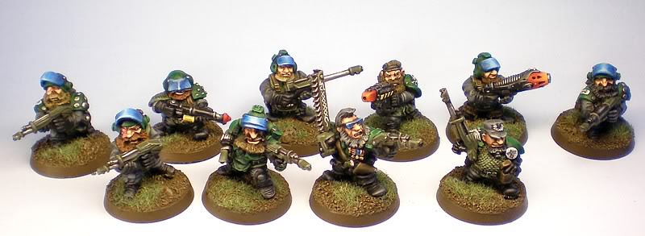

Armoury
These lists detail the points values of various items of wargear available to units in your army. Many unit entries in the army list that follows may include wargear options from one or more of these lists in each instance, the army list entry will tell you (in bold text) exactly which of these lists you may use.

Ranged Weapons
A model may replace his Gromril Axe or Ripper with one of the following:
- Plasma pistol......................................................................15 pts
- Grav pistol..........................................................................15 pts

Melee Weapons
A model may replace his Gromril Axe or Ripper with one of the following:
- Heat hammer.....................................................................25 pts
- Lightning claw....................................................................15 pts
- Power fist...........................................................................25 pts
- Power Axe..........................................................................15 pts

Exo Armour weapons
May replace Ripper with one of the following:
- Heat Hammer.....................................................................15 pts
- Lightning Claw....................................................................10 pts
May replace Power Axe with one of the following:
- Powerfist............................................................................10 pts
- Chainfist.............................................................................15 pts
- Lightning Claw......................................................................5 pts
- Storm Shield.........................................................................5 pts

Heavy Weapons
A model may replace his Ripper with one of the following:
- Heavy Bolter........................................................................10 pts
- Autocannon.........................................................................10 pts
- Lascannon............................................................................20 pts
- Multimelta...........................................................................10 pts
- Plasma Cannon....................................................................15 pts
- Missile Launcher (with Frag and Krak Missiles)...................15 pts
Add Flakk Missiles...................................................10 pts

Special Weapons
A model can replace is Gromril Axe or Ripper with one of the following:
- Flamer....................................................................................5 pts
- Meltagun..............................................................................10 pts
- Plasma Gun...........................................................................15 pts
- Grav Gun...............................................................................15 pts

Wargear
A model can take up to one each of the following:
- Bike......................................................................................20 pts
- Melta Bombs........................................................................5 pts
- Bionic Arm...........................................................................10 pts
- Bionic Eye............................................................................15 pts
- Steel Skull............................................................................15 pts
- Organ Augmetic Implants....................................................15 pts

Runic Items
Only one of each runic item may be taken per army.
- Forgefathers Hammer........................................................35 pts
- Demiurg Armour.................................................................65 pts
- Fell Axe...............................................................................35 pts
- Tankard Of Halon................................................................50 pts
- Grudge settler.....................................................................25 pts
- Rasmus Codex....................................................................40 pts

Vehicle upgrades
- Extra armour......................................................................10 pts
- Dozer Blade..........................................................................5 pts
- Ceramite Plating.................................................................10 pts
- Onboard AI Processor.........................................................15 pts
- Refractive Camouflage........................................................25 pts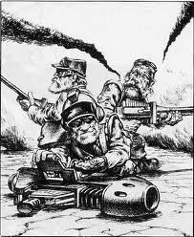
Army List
HQ
NOBLE
 | WS | BS | S | T | W | I | A | LD | SV | Type | Unit Composition | Page
Noble | 6 | 6 | 4 | 5 | 3 | 3 | 3 | 10 | 3+ | Infantry | 1 Noble | 15

Wargear:
- Hearthguard Armour
- Ripper
- Gromril Axe
- Rad Grenades
- Forcefield Generator

Special Rules:
- Squat
- Independent Character
- Inspiring Leader

Options:
- May replace Ripper with Boltgun.....................................................................Free
- May Replace Hearthguard Armour with Tech Suit...........................................20 pts
- A Noble in Hearthguard Armour or a Tech Suit may take items from the Melee Weapons, Ranged Weapons, Wargear and Runic Items lists.
- May replace Hearthguard Armour, Ripper and Gromril Axe with Mk II Exo Armour, Power Axe and Ripper................................................................................................25 pts
- A Noble in MkII Exo Armour may take items from the Exo Armour Weapons, Wargear and Runic Items lists.
Household Guard: If a detachment contains a Noble, One unit of Hearthguard may be taken as Troops instead of Elites.

Guild Biker Assault: If a detachment contains a Noble on Bike, one unit of Bikes may be taken as Troops instead of Fast Attack.
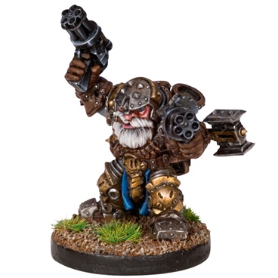
HQ
THANE 85 pts
 | WS | BS | S | T | W | I | A | LD | SV | Type | Unit Composition | Page
Thane | 5 | 5 | 4 | 4 | 2 | 2 | 2 | 10 | 3+ | Infantry | 1 Thane | 15

Wargear:
- Hearthguard Armour
- Ripper
- Gromril Axe
- Rad Grenades
- Forcefield Generator

Special Rules:
- Squat
- Independent Character
- Inspiring Leader

Options:
- May replace Ripper with Boltgun.....................................................................Free
- May Replace Hearthguard Armour with Tech Suit...........................................20 pts
- A Thane in Hearthguard Armour or a Tech Suit may take items from the Melee Weapons, Ranged Weapons, Wargear and Runic Items lists.
- May replace Hearthguard Armour, Ripper and Gromril Axe with Mk II Exo Armour, Power Axe and Ripper..................................................................................................25 pts
- A Thane in MkII Exo Armour may take items from the Exo Armour Weapons, Wargear and Runic Items lists.
Guild Biker Assault: If a detachment contains a Thane on Bike, one unit of Bikes may be taken as Troops instead of Fast Attack.
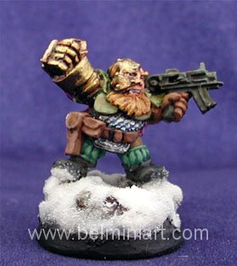
HQ
LIVING ANCESTOR 75 pts
 | WS | BS | S | T | W | I | A | LD | SV | Type | Unit Composition | Page
Living Ancestor | 4 | 4 | 3 | 4 | 2 | 2 | 2 | 10 | 3+ | Infantry | 1 Ancestor | 15

Wargear:
- Hearthguard Armour
- Ripper
- Gromril Axe
- Rad Grenades
- Psionic Nullifier

Special Rules:
- Squat
- Independent Character
- Master Tactician
- Strategic Advisor

Options:
- May replace Ripper with Boltgun.....................................................................Free
- An Ancestor may take items from the Melee Weapons, Ranged Weapons, Wargear and Runic Items lists.
- May replace Hearthguard Armour, Ripper and Gromril Axe with Mk II Exo Armour, Power Axe and Ripper...................................................................................................25 pts
- An Ancestor in MkII Exo Armour may take items from the Exo Armour Weapons, Wargear and Runic Items lists.

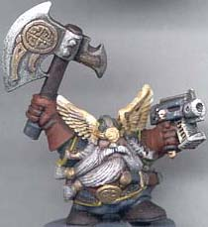
HQ
STORMRAGE VETERAN 125 pts
 | WS | BS | S | T | W | I | A | LD | SV | Type | Unit Composition | Page
Stormrage Vet. | 6 | 2 | 4 | 5 | 3 | 2 | 3 | 9 | 5+ | Infantry | 1 Stormrage Vet. | 18

Wargear
- Rager Harness
- Two Power Axes
- Frag Grenades

Special Rules
- Squat
- Independent Character
- Furious Charge
- Rage
- Fearless
- Monster Hunter
- Tough As Nails
- Deathwish

Options:
- May replace Power Axes with a single Heat Hammer......................................Free
- May take items from the Wargear and Runic Items Lists
A Stormrage Veteran may NOT use Demiurg Armour or the Grudge Settler, nor may he ride a Bike.

If A Stormrage Veteran is your Warlord, Stormragers become Troops choices instead of Elites.

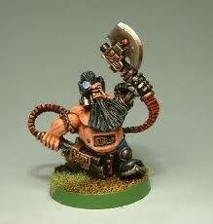
HQ
ENGINEER GUILDMASTER 85 pts
 | WS | BS | S | T | W | I | A | LD | SV | Type | Unit Composition | Page
Guildmaster | 4 | 4 | 4 | 4 | 2 | 2 | 2 | 9 | 2+ | Infantry | 1 Guildmaster | 16

Wargear:
- Tech Suit
- Ripper
- Servo Harness
- Rad Grenades

Special Rules:
- Squat
- Independent Character
- Field Repair
- Bolster Defences

Options:
- May replace Ripper with Boltgun.....................................................................Free
- May take items from the Melee Weapons, Ranged Weapons, Wargear and Runic Items lists.
- May take Conversion Beamer..........................................................................20 pts
-OR-
- May take Grav Cannon.....................................................................................20 pts
-OR-
- May Take Mining Laser.....................................................................................15 pts
-OR-
- May Exchange Plasma Cutter for Heavy Plasma Cutter....................................15 pts
- May take up to 3 Servo-droids....................................................................5 pts each
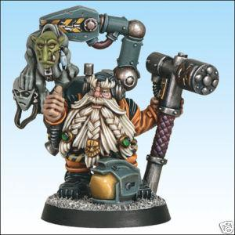
HQ
ADVISORY COUNCIL 75 pts
You may take one Council for each Noble, Thane or Ancestor in your army. This does not use up a force organisation slot.
 | WS | BS | S | T | W | I | A | LD | SV | Type | Unit Composition | Page
Advisor | 4 | 4 | 4 | 4 | 1 | 2 | 2 | 9 | 3+ | Infantry | 5 Advisors | 17
Champion | 5 | 4 | 4 | 4 | 1 | 2 | 2 | 9 | 3+ | Infantry (C)

Wargear:
- Hearthguard Armour
- Ripper
- Gromril Axe
- Rad Grenades

Special Rules:
- Squat
- Death Before Dishonour (Champion only)

Options:
- One Advisor may take Household Standard..................................................................50 pts
- One Advisor may be upgraded to a Household Champion, replacing his Gromril Axe with a Power Axe and adding a Storm Shield...........................................................................15 pts
- One Advisor may be upgraded to a Medic, taking a Medikit.........................................15 pts
- Any Advisor may take Melta Bombs....................................................................5 pts/model
- Any Advisor may take a Storm Shield................................................................10 pts/model
- Any Advisor may exchange his Ripper for a Boltgun........................................................Free
- Any Advisor may take items from the Melee Weapons, Special Weapons and/or Ranged Weapons lists
- The unit may select a Termite or Iron Grumbler as a dedicated transport vehicle.

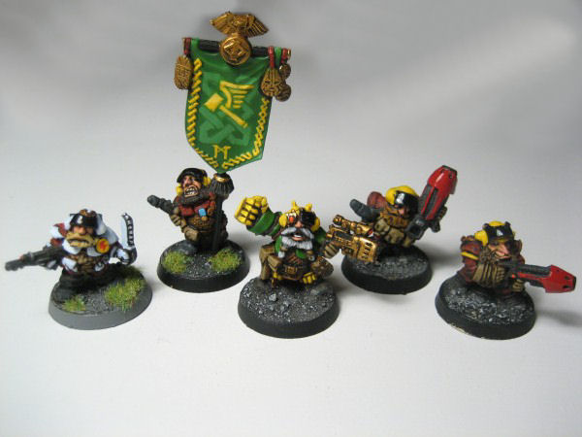
ELITE
HEARTHGUARD 100 pts
 | WS | BS | S | T | W | I | A | LD | SV | Type | Unit Composition | Page
Hearthguard | 4 | 4 | 4 | 4 | 1 | 2 | 2 | 9 | 3+ | Infantry | 4 Hearthguard | 18
Hearthcaptain | 4 | 4 | 4 | 4 | 1 | 2 | 2 | 9 | 3+ | Infantry (C) | 1 Hearthcaptain

Wargear:
- Hearthguard Armour
- Ripper
- Rad Grenades

Special Rules:
- Squat
- Fearless

Options:
- May include up to 5 additional Hearthguard.........................................................20 pts/model
- Any model may swap his Ripper for a Heavy Ripper...............................................5 pts/model
- Any model may take a Gromril Axe.........................................................................2 pts/model
- Any model may take items from the Melee Weapons or Special Weapons lists
- One Model in 5 may take an item from the Heavy Weapons list
- The Hearthcaptain may take items from the Ranged Weapons, Melee Weapons and Wargear lists, but may not choose a Bike
- The unit may select a Termite or Iron Grumbler as a dedicated transport choice.

ELITE
Mk II EXO ARMOURED HEARTHGUARD 175 pts
 | WS | BS | S | T | W | I | A | LD | SV | Type | Unit Composition | Page
Hearthguard | 4 | 4 | 4 | 4 | 1 | 2 | 2 | 9 | 2+ | Infantry | 4 Exo Hearthguard | 19
Hearthcaptain | 4 | 4 | 4 | 4 | 1 | 2 | 2 | 9 | 2+ | Infantry (C) | 1 Exo Hearthcaptain

Wargear:
- Mk II Exo Armour
- Heavy Ripper
- Power Fist

Special Rules:
- Squat
- Fearless
- Relentless

Options:
- May include up to 5 additional Exo Armoured Hearthguard..................................35pts/model
- Any model may replace his power fist with a Chainfist...........................................5 pts/model
- For every 5 models in the squad one model may choose one of the following:
-Replace Heavy Ripper with Heavy Flamer............................................................10 pts/model
-Replace Heavy Ripper with Ripper Minigun...................................................20 pts/model
- Entire squad may instead exchange Heavy Ripper and Powerfist for:
-Heat Hammer and Storm Shield............................................................................ 5 pts/model
-Two Lightning Claws...........................................................................................................Free
- The unit may select a Termite or Iron Grumbler as a dedicated transport choice.
ELITE
MINING GUILD 45 pts
 | WS | BS | S | T | W | I | A | LD | SV | Type | Unit Composition | Page
Miner | 4 | 3 | 3 | 4 | 1 | 2 | 1 | 8 | 4+ | Infantry | 4 Miners | 19
Foreman | 4 | 4 | 3 | 4 | 1 | 2 | 2 | 8 | 4+ | Infantry | 1 Foreman

Wargear:
- Combat Armour
- Scatter Gun
- Gromril Axe
- Frag Grenades

Special Rules:
- Squat
- Deep Strike
- Night Vision

Options:
- May include up to 5 additional Miners..................................................................9 pts/model
- Entire squad may be equipped with:
-Krak Grenades.......................................................................................................2 pts/model
-Melta Bombs.........................................................................................................5 pts/model
- Up to two models may exchange their Scatter Guns with one of the following:
-Flamer...................................................................................................................5 pts/model
-Plasma Cutter.....................................................................................................15 pts/model
- One model may take a Demolition Charge......................................................................20 pts
- The Foreman may take items from the Ranged Weapons and Melee Weapons lists.

ELITE
ENGINEER 50 pts
You may take one Engineer for each Noble, Thane or Engineer Guildmaster in your army. This does not use up a force organisation slot.
 | WS | BS | S | T | W | I | A | LD | SV | Type | Unit Composition | Page
Engineer | 4 | 4 | 4 | 4 | 1 | 2 | 1 | 9 | 2+ | Infantry (C) | 1 Engineer | 16

Wargear:
- Tech Suit
- Ripper
- Servo Arm
- Rad Grenades

Special Rules:
- Squat
- Independent Character
- Field Repair
- Bolster Defences

Options:
- May upgrade Servo Arm to Servo Harness....................................................................25 pts
- May take items from the Ranged Weapons, Melee Weapons and Wargear lists
- May take up to 3 servo-droids....................................................................................5 pts each

ELITE
STORMRAGERS 75 pts
 | WS | BS | S | T | W | I | A | LD | SV | Type | Unit Composition | Page
Stormrager | 5 | 2 | 4 | 4 | 1 | 2 | 2 | 8 | 5+ | Infantry | 5 Stromragers | 18

Wargear
- Rager Harness
- Two Gromril Axes
- Frag Grenades

Special Rules
- Squat
- Furious Charge
- Rage
- Fearless
- Monster Hunter
- Tough As Nails
- Deathwish

Options:
- May include up to 5 additional Stormragers..........................................................15 pts/model
- Any model may exchange his Gromril Axes for a Heat Hammer...........................25 pts/model
- For every 5 models in the unit one model may choose to exchange his Gromril Axes for:
- A pair of Lightning Claws.................................................................................20 pts/model
- A Pair of Power Axes........................................................................................20 pts/model

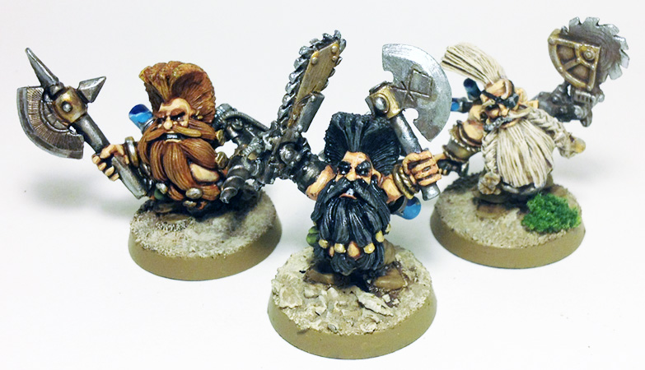

ELITE
IRON ANCESTOR 75 pts
 | WS | BS | S | Front | Side | Rear | I | A | HP | Type | Page
Iron Ancestor | 4 | 4 | 5 | 12 | 12 | 10 | 2 | 2 | 3 | Vehicle (Walker) | 20

Wargear:
- Heat Hammer
- Twin Linked Autocannon
- Searchlight
- Smoke Launchers

Special Rules:
- Squat

Options:

- May replace Twin Linked Autocannon with:
-Multimelta........................................................................................................5 pts
-Twin Linked Heavy Bolter.................................................................................5 pts
-Assault Cannon...............................................................................................20 pts
-Twin Linked Lascannon...................................................................................25 pts
- May replace Heat Hammer with:
-Twin Linked Autocannon.................................................................................15 pts
-Missile Launcher with Frag and Krak missiles..................................................10 pts
- May take a Termite as a Dedicated Transport Vehicle
- May take items from the Vehicle Upgrades list
May not take Onboard AI Processor or Dozer Blade
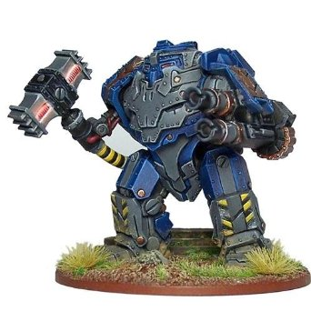

TROOPS
COMBAT SQUAD 45 pts

 | WS | BS | S | T | W | I | A | LD | SV | Type | Composition | Page
Squat | 4 | 3 | 3 | 4 | 1 | 2 | 1 | 8 | 4+ | Infantry | 4 Squats | 21
Squat Sgt | 4 | 3 | 3 | 4 | 1 | 2 | 1 | 8 | 4+ | Infantry (C) | 1 Sergeant
Vet Squat Sgt | 4 | 3 | 3 | 4 | 1 | 2 | 2 | 9 | 4+ | Infantry (C)

Wargear:
- Combat Armour
- Ripper
- Rad Grenades

Special Rules:
- Squat

Options:
- May include up to 5 additional Squat Warriors......................................................9 pts/model
- May upgrade Squat Sergeant to a Veteran Sergeant........................................................10 pts
- The entire unit may exchange their Rippers for Boltguns...................................................Free
- If the squad numbers less than ten models one Squat may take one item from either the Special Weapons or Heavy Weapons list
- If the squad numbers ten models, one Squat may take one item from the Special Weapons list and one other Squat may take one item from the Heavy Weapons list.
- The Squat Sergeant or Veteran Sergeant may take items from the Melee Weapons and/or Ranged Weapons lists
- The Squat Sergeant or Veteran Sergeant may take Melta Bombs......................................5 pts
- The unit may select a Termite or Iron Grumbler as a Dedicated Transport

TROOPS
COMBAT DROIDS 100 pts
 | WS | BS | S | T | W | I | A | LD | SV | Type | Unit Composition | Page
Combat Droid | 2 | 2 | 3 | 3 | 1 | 3 | 1 | 5 | 5+ | Infantry | 20 Droids | 22

Wargear
- Battle Chassis
- Ripper

Special Rules
- Automaton

Options:
- May include up to 30 additional Combat Droids.....................................................5 pts/model
- For every full ten models in the unit one Droid may choose one item from the Special Weapons list.
- May select an Ore Hauler as a Dedicated Transport Vehicle
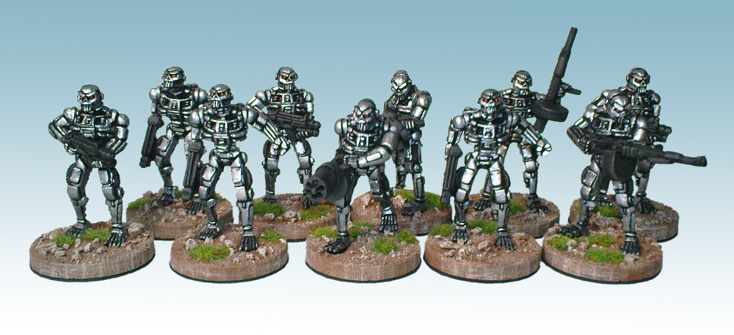

TRANSPORT VEHICLES
IRON GRUMBLER 35 pts
 | BS | F | S | R | HP | Type | Unit Composition | Page
Iron Grumbler | 4 | 11 | 11 | 10 | 3 | Vehicle (Tank, Transport) | 1 Iron Grumbler | 26

Wargear
- Heavy Ripper
- Searchlight
- Smoke Launcher

Special Rules
- Repair

Transport Capacity
- Twelve Models

Options
- Iron Grumblers may take items from the Vehicle Upgrades list.

TERMITE 40 pts
 | BS | F | S | R | HP | Type | Unit Composition | Page
Termite | 4 | 12 | 12 | 12 | 3 | Vehicle (Tank, Transport) | 1 Termite | 28

Wargear
- Heavy Ripper
- Searchlight
- Smoke Launcher

Special Rules
- Tunneller

Transport Capacity
- Twelve Models

Options
- Termites may take items from the Vehicle Upgrades list.

ORE HAULER 40 pts
 | BS | F | S | R | HP | Type | Unit Composition | Page
Ore Hauler | 3 | 13 | 12 | 10 | 3 | Vehicle (Tank, Transport) | 1 Ore Hauler | 27

Wargear
- Heavy Ripper
- Searchlight
- Smoke Launcher

Special Rules
- Droid Racks

Transport Capacity
- Fifteen Models

Options
- Ore Haulers may take items from the Vehicle Upgrades list.

FAST ATTACK
GUILD BIKER SQUAD 60 pts

 | WS | BS | S | T | W | I | A | LD | SV | Type | Composition | Page
Biker | 4 | 3 | 3 | 5 | 1 | 2 | 1 | 8 | 4+ | Bike | 2 Bikers | 25
Hearthguard | 4 | 4 | 4 | 5 | 1 | 2 | 2 | 9 | 3+ | Bike (C) | 1 Hearthguard
Trike | 4 | 3 | 3 | 5 | 2 | 2 | 2 | 8 | 4+ | Bike

Wargear
- Combat Armour
- Ripper
- Frag Grenades
- Krak Grenades
- Squat Bike
- Hearthguard Armour (Hearthguard Only)

Special Rules
- Squat

Options
- May include up to five additional Squat Bikers......................................................20 pts/model
- Up to two Squat Bikers may each take one item from the Special Weapons list
- The Hearthguard Biker may take items from the Melee Weapons and/or Ranged Weapons lists.
- The Hearthguard may take Melta Bombs...........................................................................5 pts
- The squad may include one Squat Trike............................................................................40 pts
- The Trike may replace its Heavy Ripper with a Ripper Minigun .................................10 pts
- The Trike may replace its Heavy Ripper with a Multimelta.........................................10 pts

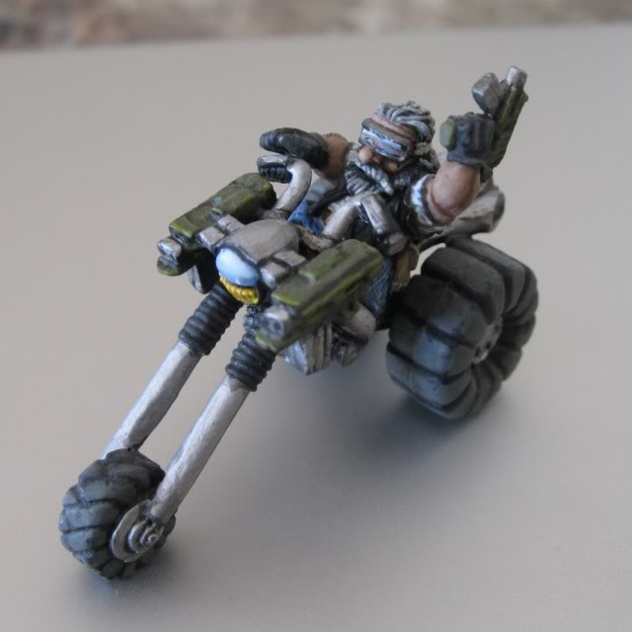
FAST ATTACK
GUILD TRIKE SQUAD 40 pts

 | WS | BS | S | T | W | I | A | LD | SV | Type | Composition | Page
Trike | 4 | 3 | 3 | 5 | 1 | 2 | 1 | 8 | 4+ | Bike | 1 Trike | 25
Hearthguard | 4 | 4 | 4 | 5 | 1 | 2 | 2 | 9 | 3+ | Bike (C)

Wargear
- Combat Armour
- Ripper
- Frag Grenades
- Krak Grenades
- Squat Bike
- Hearthguard Armour (Hearthguard Only)

Special Rules
- Squat

Options
- May include up to two additional Squat Trikes......................................................40 pts/model
- Any Trike may replace its Heavy Ripper with one of the following:
-Multimelta........................................................................................................................10 pts
-Eradicator Minigun...........................................................................................................10 pts
-Plasma Cannon.................................................................................................................15 pts
- May include a Hearthguard Biker......................................................................................25pts
- The Hearthguard Biker may take items from the Melee Weapons and/or Ranged Weapons lists.
- The Hearthguard may take Melta Bombs...........................................................................5 pts

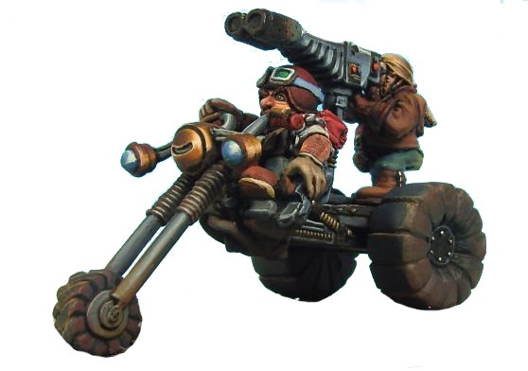
FAST ATTACK
GUILD QUAD 60 pts
 | BS | F | S | R | HP | Type | Unit Composition | Page
Quad | 3 | 10 | 10 | 10 | 2 | Vehicle (Fast) | 1 Quad | 25

Wargear:
- Twin Linked Ripper

Special Rules:
- Jink

Options:

- May include up to two additional Quads...............................................................60 pts/model
- Any Quad may replace its Twin Linked Ripper with:
-Light Missile Pod...................................................................................................15 pts/model
- Any Quad may take items from the Vehicle Upgrades list

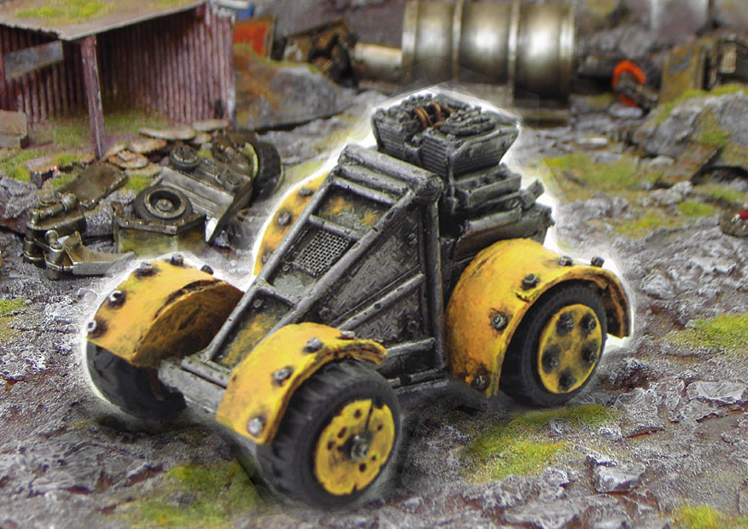

FAST ATTACK
SURVEY DRONE 60 pts
 | WS | BS | S | Front | Side | Rear | I | A | HP | Type | Page
Survey Drone | 3 | 3 | 5 | 10 | 10 | 10 | 3 | 1 | 2 | Vehicle (Walker) | 22

Wargear:
- Heavy Bolter
- Refractive Camouflage
- Sensor Array

Special Rules:
- Automaton
- Scout
- Move Through Cover

Options:

- May exchange its Heavy Bolter for one of the following:
- Autocannon................................................................................................................5 pts
- Ripper Minigun...................................................................................................10 pts

A Detachment can include up to 3 Survey Drones as a single Fast Attack choice

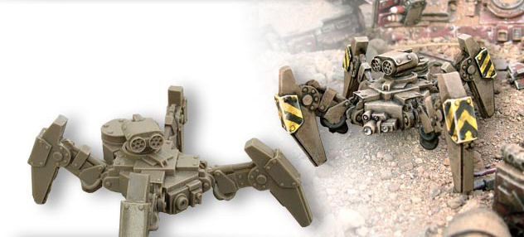

FAST ATTACK
BERSERKER SQUAD 45 pts
 | WS | BS | S | T | W | I | A | LD | SV | Type | Unit Composition | Page
Squat | 4 | 3 | 3 | 4 | 1 | 2 | 1 | 8 | 4+ | Infantry | 4 Berserkers | 21
Squat Sergeant | 4 | 3 | 3 | 4 | 1 | 2 | 1 | 8 | 4+ | Infantry (C) | 1 Sergeant
Vet sergeant | 4 | 3 | 3 | 4 | 1 | 2 | 2 | 9 | 4+ | Infantry (C)

Wargear:
- Combat Armour
- Light Ripper
- Gromril Axe
- Frag Grenades
- Krak Grenades

Special Rules:
- Squat

Options:
- May include up to 5 additional Squat Warriors......................................................9 pts/model
- May upgrade Squat Sergeant to a Veteran Sergeant........................................................10 pts
- Up to two Squats may replace their Light Ripper with one of the following:
-Flamer.....................................................................................................................5 pts/model
-Plasma Pistol.........................................................................................................15 pts/model
- Any Squat who does not take one of the above options may exchange his Gromril Axe for a Power Axe..............................................................................................................15 pts/model
- The Squat Sergeant or Veteran Sergeant may take items from the Ranged Weapons and/or Melee Weapons lists
- The Squat Sergeant or Veteran Sergeant may take Melta Bombs.......................................5 pts
- The unit may take a Termite or Iron Grumbler as a Dedicated Transport

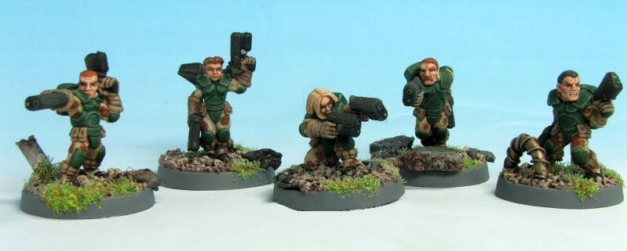

HEAVY SUPPORT
THUNDERER SQUAD 45 pts

 | WS | BS | S | T | W | I | A | LD | SV | Type | Composition | Page
Squat | 4 | 3 | 3 | 4 | 1 | 2 | 1 | 8 | 4+ | Infantry | 4 Squats | 21
Squat Sgt | 4 | 3 | 3 | 4 | 1 | 2 | 1 | 8 | 4+ | Infantry (C) | 1 Sergeant
Vet Squat Sgt | 4 | 3 | 3 | 4 | 1 | 2 | 2 | 9 | 4+ | Infantry (C)

Wargear:
- Combat Armour
- Ripper
- Rad Grenades
- Signum (Sergeant or Veteran Sergeant only)

Special Rules:
- Squat

Options:
- May include up to 5 additional Squat Warriors......................................................9 pts/model
- May upgrade Squat Sergeant to a Veteran Sergeant........................................................10 pts
- The Sergeant or Veteran Sergeant may take items from the Melee Weapons and/or Ranged Weapons lists
- The Squat sergeant or Veteran sergeant may take Melta Bombs.......................................5 pts
- Up to Four Squats may each take one weapon from the Heavy Weapons list
- The unit may select an Iron Grumbler or Termite as a Dedicated Transport
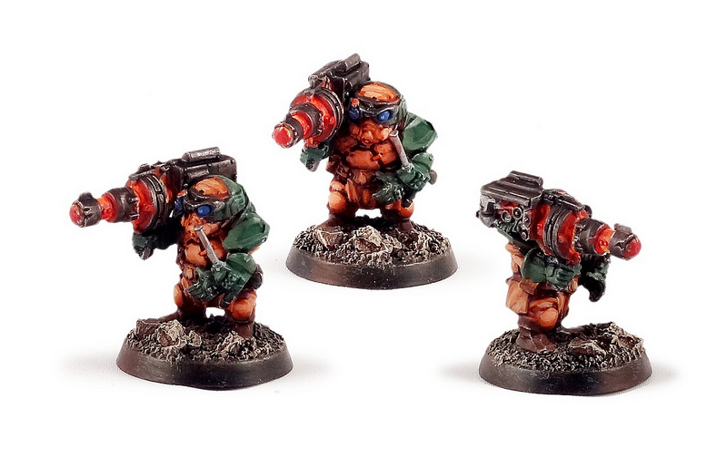

HEAVY SUPPORT
HEAVY COMBAT DROID 120 pts
 | WS | BS | S | T | W | I | A | LD | SV | Type | Unit Composition | Page
Heavy Droid | 4 | 3 | 8 | 8 | 3 | 3 | 3 | 5 | 3+ | Monstrous Creature (Character) | 1 Heavy Droid | 23

Wargear
- Heavy Plasma Cutter

Special Rules
- Automaton

Options
- May be fitted with up to two Flamers......................................................................5 pts each
- May exchange the Heavy Plasma Cutter for:
-Ripper Minigun...........................................................................................................10 pts
-Mining Laser.....................................................................................................................15 pts
-Grav Cannon.....................................................................................................................25 pts

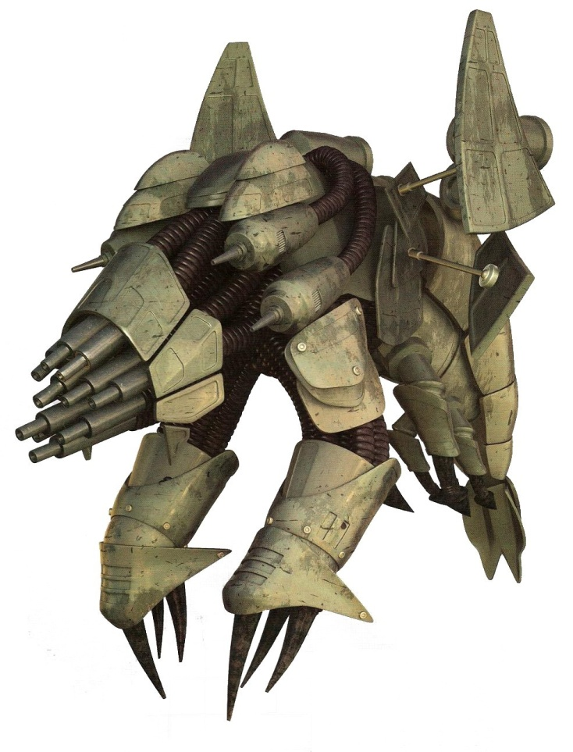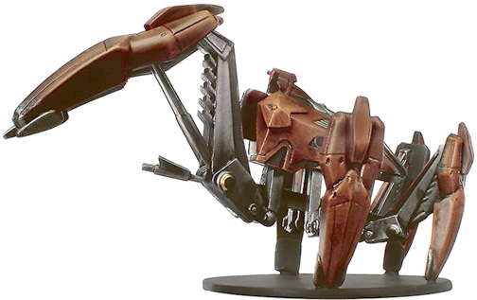
Heavy droids come in many different configurations depending on which Household they belong to.

HEAVY SUPPORT
THUDD GUN 90 pts
 | WS | BS | S | T | W | I | A | LD | SV | TYPE | UNIT COMPOSITION
Squat Crew | 4 | 3 | 3 | 4 | 1 | 2 | 1 | 8 | 4+ | Artillery | 2 Squat Crew
Thudd Gun | - | - | - | 7 | 2 | - | - | - | 3+ | Artillery | 1 Thudd Gun

Wargear (crew only):
- Combat Armour
- Ripper

Wargear (Artillery only):
- Thudd Gun

Special Rules (crew only):
- Squat

HEAVY SUPPORT
MINING LASER 100 pts
 | WS | BS | S | T | W | I | A | LD | SV | TYPE | UNIT COMPOSITION
Squat Crew | 4 | 3 | 3 | 4 | 1 | 2 | 1 | 8 | 4+ | Artillery | 2 Squat Crew
Mining Laser | - | - | - | 7 | 2 | - | - | - | 3+ | Artillery | 1 Mining Laser

Wargear (crew only):
- Combat Armour
- Ripper

Wargear (Artillery only):
- Mining Laser

Special Rules (crew only):
- Squat

HEAVY SUPPORT
THUNDERFIRE CANNON 80 pts
 | WS | BS | S | T | W | I | A | LD | SV | TYPE | UNIT COMPOSITION
Squat Crew | 4 | 3 | 3 | 4 | 1 | 2 | 1 | 8 | 4+ | Artillery | 2 Squat Crew
Thunderfire | - | - | - | 7 | 2 | - | - | - | 3+ | Artillery | 1 Thunderfire Cannon

Wargear (crew only):
- Combat Armour
- Ripper

Wargear (Artillery only):
- Thunderfire Cannon

Special Rules (crew only):
- Squat

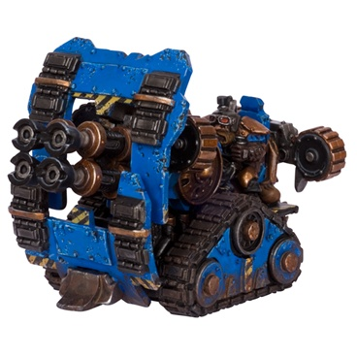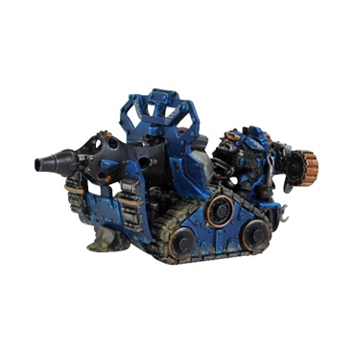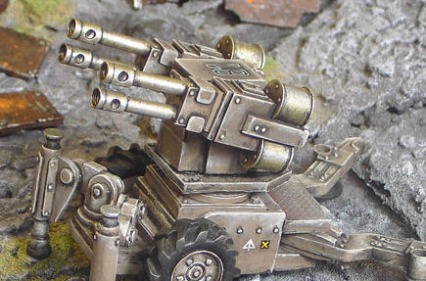 Squat Thudd Gun Mining Laser Thunderfire Cannon
HEAVY SUPPORT
MOLE MORTAR TEAM 30 pts

 | WS | BS | S | T | W | I | A | LD | SV | Type | Composition
Squat | 4 | 3 | 3 | 4 | 1 | 2 | 1 | 8 | 4+ | Infantry | 2 Squats

Wargear:
- Combat Armour
- Mole Mortar
- Ripper

Special Rules:
- Squat

Options:
- May include up to 2 additional Mortar Teams.....................................................30 pts/model
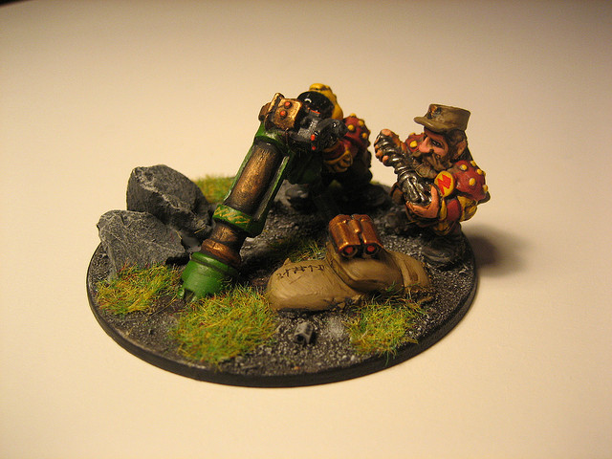

HEAVY SUPPORT
LAND TRAIN 280 pts
 | BS | F | S | R | HP | Type | Unit Composition
Land Train Engine | 4 | 14 | 13 | 11 | 4 | Heavy Vehicle (Tank) | 1 Engine
Land Train Battlecar | 4 | 10 | 12 | 10 | 3

Wargear (Engine):
- Battlecannon
- Exterminator Autocannon
- Heavy Ripper
- Forceshield Generator
- Dozer Blade
- Searchlight
- Smoke Launcher

Wargear (Berserker Battlecar):
- Heavy Ripper
- Shield Booster

Wargear (Mortar Battlecar):
- Heavy Mortar
- Shield Booster

Wargear (Dragon Battlecar)
- Inferno Cannon
- Shield Booster

Wargear (Bomb Battlecar)
- Rad Bomb
- Shield Booster

Wargear (Hydra Battlecar)
- Thunderfire Cannon
- Shield Booster

Special Rules (Engine):
- Land Train
- Behemoth

Special Rules (Berserker Battlecar):
- Transport Capacity 12

One unit of Berserkers may begin the game deployed inside the Berserker Battlecar

Special Rules (Mortar Battlecar):
- Accurate Bombardment

Special Rules (Dragon Battlecar):
- None

Special Rules (Bomb Battlecar):
- One Shot Weapon

Special Rules (Hydra Battlecar):
- None

Options:

- May attach one each of the following:
- Berserker Battlecar......................................................................................................60 pts
- Mortar Battlecar..........................................................................................................70 pts
- Dragon Battlecar..........................................................................................................65 pts
- Bomb Battlecar............................................................................................................90 pts
- Hydra Battlecar............................................................................................................80pts

The Iron Duke
THE IRON DUKE 200 pts
If The Iron Duke is your Warlord do not generate his warlord trait normally. He will always have the Iron Resolve trait.
 | WS | BS | S | T | W | I | A | LD | SV | Type | Unit Composition
Iron Duke | 7 | 6 | 5 | 6 | 3 | 3 | 3 | 9 | 3+ | Infantry (C) | The Duke

Wargear:
- Hearthguard Armour
- Ripper
- Melta Blade
- Rad Grenades
- Forcefield Generator

Special Rules:
- Squat
- Independent Character
- Feel No Pain
- Fear
- You Have Failed Me For The Last Time

Melta Blade
WEAPON | R | S | AP | SPECIAL
Melta Blade | - | User | 2 | Melee, Armourbane, Rending, Soulblaze, Specialist Weapon

You Have Failed Me For The Last Time
If a friendly unit within 8” of the Iron Duke fails a Morale test he will summarily execute the squad’s current commander- this is the model in the squad with the highest leadership value
If two or more models have the same leadership value, randomly determine which one is executed (this cannot be the Duke himself)
The executed model is immediately removed as a casualty, regardless of number of wounds remaining. The unit in question must then re-roll the failed morale check- if this test also fails then the squad falls back as normal.
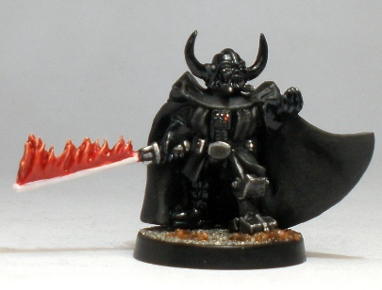

Engineer Grymm

ENGINEER GRYMM 105 pts
 | WS | BS | S | T | W | I | A | LD | SV | Type | Unit Composition
Grymm | 4 | 4 | 3 | 4 | 2 | 3 | 2 | 8 | 2+ | Infantry | Grymm

Wargear:
- Tech Suit
- Advanced Ripper
- Servo Harness
- Rad Grenades

Special Rules:
- Squat
- Independent Character
- Insane
- Tinkerer
- Repair (works on a 4+)

WEAPON | R | S | AP | SPECIAL
Advanced Ripper | 18 | 5 | 3 | Assault 3, Shred

Insane
Grymm is completely Fearless
Every time Grymm wishes to Move, Shoot or Charge he must first pass a Leadership test. If the test is failed the action is forfeit and he can do nothing that phase

Tinkerer
If Grymm is deployed with a unit roll a D6 at the start of the game as he tinkers with their equipment. All results apply for the duration of the game.
D6 | Result
1 | Aesthetic Alteration: While visually stunning, this has no noticeable effect
2 | Improved Targeter: All non-template shooting weapons in the unit have their maximum range increased by 12”
3 | Reinforced Armour: Models in the unit treat their armour save as being one better than normal.
4 | Armour Piercing Ammo: All shooting weapons in the unit are Rending
5 | Personal Forcefields: All models in the unit have a 5+ Invulnerable Save
6 | Flash Of Brilliance: Roll Twice more on the table and apply both results. Each upgrade can only be applied once. Ignore duplicate results (including additional 6’s)

SKAGG THE STEALTHY
Skagg 95 pts

 | WS | BS | S | T | W | I | A | LD | SV | Type | Composition
Skagg | 3 | 7 | 3 | 4 | 2 | 2 | 1 | 8 | 4+ | Infantry | Skagg

Wargear:
- Combat Armour
- Exitus Rifle
- Refractive Personal Camouflage

Special Rules:
- Squat

WEAPON | R | S | AP | SPECIAL
Exitus Rifle | 36 | X | 1 | Heavy 1, Sniper, Fleshbane

Refractive Personal Camouflage
This unique piece of equipment gives Skagg the Shrouded Special Rule if he does not move in the Squat movement phase and the Stealth special rule if he does.
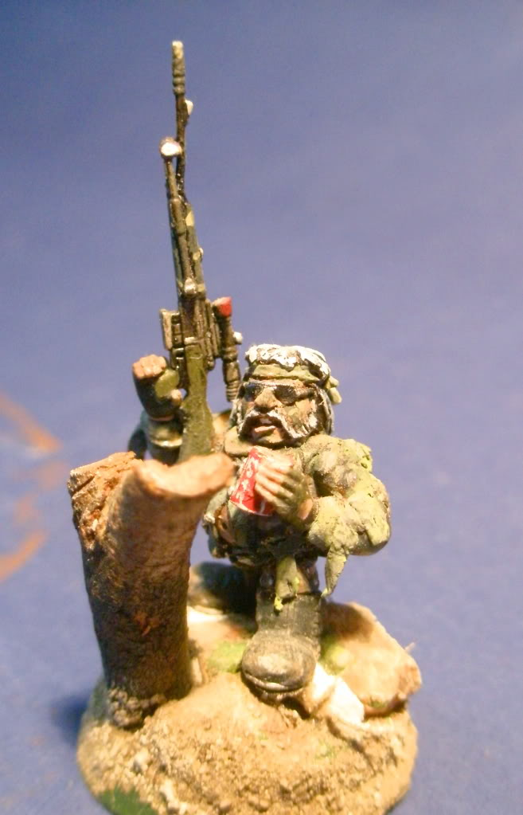

COMBAT DROID AA-23
AA-23 75 pts

 | WS | BS | S | T | W | I | A | LD | SV | Type | Composition
AA-23 | 3 | 3 | 3 | 3 | 3 | 3 | 1 | 8 | 5+ | Infantry(C) | AA-23

Wargear:
- Battle Chassis
- Ripper

Special Rules:
- Automaton
- Independent Character
- Self Repair Algorithm

Options:
- AA-23 may exchange his Ripper for any one weapon from the Heavy Weapons list.
Self Repair Algorithm:
AA-23 is adept at repairing his own Battle Chassis using whatever materials are to hand. Other Combat drones, discarded weapons, even scrap metal or parts of wrecked vehicles. This resourcefulness grants him the Eternal Warrior and It Will Not Die Special Rules.
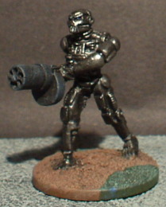

Oswynn Sevrinsdottir
OSWYNN SEVRINSDOTTIR 135 pts
If Oswynn is your Warlord do not generate her warlord trait normally. She will always have the Scientist trait.
 | WS | BS | S | T | W | I | A | LD | SV | Type | Composition
Oswynn | 5 | 5 | 4 | 4 | 3 | 2 | 2 | 9 | 3+ | Infantry(C) | Oswynn

Wargear:
- Hearthguard Armour
- Ripper
- Heat Hammer
- Rad Grenades
- Frag Grenades
- Force Dome Generator

Special Rules:
- Squat
- Independent Character
- Fearless
- Inspiring Leader

Force Dome Generator:
Oswynn understands forcefield technology better than any other living Squat and has extended her own belt-mounted generator to cover a larger area.
The Force Dome gives all units with a model within 6” of Oswynn a 5+ invulnerable save. The dome has no effect in close combat.
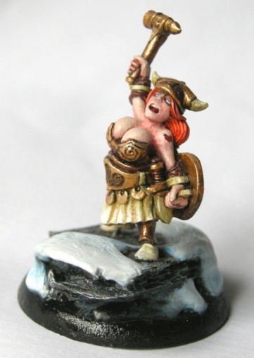

SUMMARIES
HQ
 | WS | BS | S | T | W | I | A | LD | SV
Noble | 6 | 6 | 4 | 5 | 3 | 3 | 3 | 10 | 3+
Thane | 5 | 5 | 4 | 4 | 2 | 2 | 2 | 10 | 3+
Ancestor | 4 | 4 | 3 | 4 | 2 | 2 | 2 | 10 | 3+
Engineer Guildmaster | 4 | 4 | 4 | 4 | 2 | 2 | 2 | 9 | 2+
Veteran Advisor | 4 | 4 | 4 | 4 | 1 | 2 | 2 | 9 | 3+
Household Champion | 5 | 4 | 4 | 4 | 1 | 2 | 2 | 9 | 3+
Stormrage Veteran | 6 | 2 | 4 | 5 | 3 | 2 | 3 | 9 | 5+
Stormrager | 5 | 2 | 4 | 4 | 1 | 2 | 2 | 8 | 5+
Iron Duke | 7 | 6 | 5 | 6 | 3 | 3 | 3 | 9 | 3+
Grymm | 4 | 4 | 3 | 4 | 2 | 3 | 2 | 8 | 2+
Skagg | 3 | 7 | 3 | 4 | 2 | 2 | 1 | 8 | 4+
AA-23 | 3 | 3 | 3 | 3 | 2 | 3 | 1 | 8 | 5+
Oswynn | 5 | 5 | 4 | 4 | 3 | 2 | 2 | 9 | 3+
ELITE
 | WS | BS | S | T | W | I | A | LD | SV
Engineer | 4 | 4 | 4 | 4 | 1 | 2 | 1 | 9 | 2+
Hearthcaptain | 4 | 4 | 4 | 4 | 1 | 2 | 2 | 9 | 3+
Hearthguard | 4 | 4 | 4 | 4 | 1 | 2 | 2 | 9 | 3+
Exo Armoured Hearthcaptain | 4 | 4 | 4 | 4 | 1 | 2 | 2 | 9 | 2+
Exo Armoured Hearthguard | 4 | 4 | 4 | 4 | 1 | 2 | 2 | 9 | 2+
Foreman | 4 | 4 | 3 | 4 | 1 | 2 | 2 | 8 | 4+
Miner | 4 | 3 | 3 | 4 | 1 | 2 | 1 | 8 | 4+
TROOPS
 | WS | BS | S | T | W | I | A | LD | SV
Squat | 4 | 3 | 3 | 4 | 1 | 2 | 1 | 8 | 4+
Squat Sergeant | 4 | 3 | 3 | 4 | 1 | 2 | 1 | 8 | 4+
Veteran Squat Sergeant | 4 | 3 | 3 | 4 | 1 | 2 | 2 | 9 | 4+
Combat Droid | 2 | 2 | 3 | 3 | 1 | 3 | 1 | 5 | 5+
FAST ATTACK
 | WS | BS | S | T | W | I | A | LD | SV
Squat | 4 | 3 | 3 | 4 | 1 | 2 | 1 | 8 | 4+
Squat Sergeant | 4 | 3 | 3 | 4 | 1 | 2 | 1 | 8 | 4+
Veteran Squat Sergeant | 4 | 3 | 3 | 4 | 1 | 2 | 2 | 9 | 4+
Bike | 4 | 3 | 3 | 5 | 1 | 2 | 1 | 8 | 4+
Hearthguard Biker | 4 | 4 | 4 | 5 | 1 | 2 | 2 | 9 | 3+
Trike | 4 | 3 | 3 | 5 | 2 | 2 | 2 | 8 | 4+
HEAVY SUPPORT
 | WS | BS | S | T | W | I | A | LD | SV
Squat | 4 | 3 | 3 | 4 | 1 | 2 | 1 | 8 | 4+
Squat Sergeant | 4 | 3 | 3 | 4 | 1 | 2 | 1 | 8 | 4+
Veteran Squat Sergeant | 4 | 3 | 3 | 4 | 1 | 2 | 2 | 9 | 4+
Heavy Mining Droid | 4 | 3 | 8 | 8 | 3 | 3 | 3 | 5 | 3+
Squat Crew | 4 | 3 | 3 | 4 | 1 | 2 | 1 | 8 | 4+
Artillery Piece | - | - | - | 7 | 2 | - | - | - | 3+
Vehicles
 | WS | BS | S | Front | Side | Rear | I | A | HP
Iron Ancestor | 4 | 4 | 5 | 12 | 12 | 10 | 2 | 2 | 3
Survey Drone | 3 | 3 | 5 | 10 | 10 | 10 | 3 | 1 | 2
Quad | - | 3 | - | 10 | 10 | 10 | - | - | 2
Iron Grumbler | - | 4 | - | 11 | 11 | 10 | - | - | 3
Ore Hauler | - | 3 | - | 13 | 12 | 10 | - | - | 3
Termite | - | 4 | - | 12 | 12 | 12 | - | - | 3
Land Train Engine | - | 4 | - | 14 | 13 | 11 | - | - | 4
Land Train Battlecar | - | 4 | - | 10 | 12 | 10 | - | - | 3

Weapons
WEAPON | R | S | AP | SPECIAL
Autocannon | 48 | 7 | 4 | Heavy 2
Battle Cannon | 72 | 8 | 3 | Ordnance 1, Large Blast
Boltgun | 24 | 4 | 5 | Rapid Fire
Chainfist | - | X2 | 2 | Melee, Armourbane, Specialist Weapon, Unwieldy
Conversion Beamer | 0 -18 | 6 | - | Heavy 1, Blast.
Conversion Beamer | 19 - 42 | 8 | 4 | Heavy 1, Blast.
Conversion Beamer | 43 - 72 | 10 | 1 | Heavy 1, Blast.
Demolition Charge | 6 | 8 | 2 | Assault 1, Large Blast, One Use Only
Ripper Minigun | 24 | 6 | - | Heavy 4, Shred, Rending
Exterminator | 48 | 7 | 4 | Heavy 4, Twin Linked.
Flamer | T | 4 | 5 | Assault 1
Grav Cannon | 24 | 5 | - | Salvo 3 / 5, Concussive, Graviton
Grav Gun | 18 | * | 2 | Salvo 2 / 3, Concussive, Graviton
Grav Pistol | 12 | * | 2 | Pistol, Concussive, Graviton
Gromril Axe | - | +1 | - | Melee, Unwieldy
Heat Hammer | - | X2 | 2 | Melee, Concussive, Unwieldy, Specialist Weapon, Heat Blast
Heavy Bolter | 36 | 5 | 4 | Heavy 3
Heavy Flamer | T | 5 | 4 | Assault 1
Heavy Laser: Dispersed | 60 | 5 | 6 | Heavy 1, Large Blast
Heavy Laser: Focussed | 60 | 7 | 4 | Heavy 1, Blast
Heavy Laser: Lance | 60 | 9 | 2 | Heavy 1, Lance
Heavy Mortar | 12 -48 | 6 | 4 | Ordnance Barrage 1, Large Blast.
Heavy Plasma Cutter | 18 | 6 | 2 | Assault 3,
Heavy Ripper | 24 | 5 | - | Salvo 3 / 5, Shred
Inferno Cannon | T | 6 | 4 | Heavy 1, Torrent
Lascannon | 48 | 9 | 2 | Heavy 1
Light Missile Pod | 12 | 5 | - | Heavy 1, Large Blast
Light Ripper | 12 | 3 | - | Assault 2, Shred, Counts as a pistol in hand to hand.
Lightning Claw | - | User | 3 | Melee, Shred, Specialist Weapon
Meltagun | 12 | 8 | 1 | Assault 1, Melta
Mining Laser | 36 | 8 | 2 | Heavy 1, Lance
Missile Launcher: Flakk | 48 | 7 | 4 | Heavy 1, Skyfire
Missile Launcher: Frag | 48 | 4 | 6 | Heavy 1, Blast
Missile Launcher: Krak | 48 | 8 | 3 | Heavy 1
Mole Mortar | 60 | 4 | - | Heavy 1,Barrage, Blast, Tremor
Multimelta | 24 | 8 | 1 | Heavy 1, Melta
Plasma Cannon | 36 | 7 | 2 | Heavy 1, Blast
Plasma Cutter | 12 | 6 | 2 | Assault 2, Counts as a pistol in hand to hand.
Plasma Gun | 24 | 7 | 2 | Rapid Fire
Plasma Pistol | 12 | 7 | 2 | Pistol
Power Axe | - | +1 | 2 | Melee, Unwieldy
Power Fist | - | X2 | 2 | Melee, Specialist Weapon, Unwieldy
Rad Bomb | 12-960 | 10 | 1 | Ordnance Barrage, One Use Only, D3+3” Blast. Rad.
Ripper | 18 | 4 | - | Assault 3, Shred
Scatter Gun (Close) | 6 | 5 | 4 | Assault 2, Shred.
Scatter Gun (Long) | 12 | 4 | 6 | Assault 2
Servo Arm | - | X2 | 1 | Melee, Specialist Weapon, Unwieldy
Thudd Gun | 60 | 6 | 5 | Heavy 4, Barrage, Blast.
Thunderfire Cannon | 48 | 7 | 4 | Heavy 4, Interceptor, Twin Linked, Skyfire.

